

**School of Science, Engineering, & Environment**

**MSc Software Engineering**

**2023-2024**

**Project Title: “Online Telemedicine Marketplace and Personalized Healthcare e-Shop”**

**Supervisor Name:**

**Author Name: Siva Kumar Koduri**

**Student ID: @00714747**

# Abstract

Currently, digital technologies have emerged at a great pace across multiple industries, especially the healthcare industry. The healthcare industry comprises a vast amount of complex and sensitive data, which requires careful handling and storage. The healthcare industry is looking to provide personalized patient care and healthcare services as per the specific health conditions and diseases of patients that pose a great challenge for this industry because it is not possible for the healthcare professionals to physically meet each patient, assess their health conditions, and recommend tailored medication or treatment accordingly. Thus, this project mainly intends to develop and implement an innovative and robust Online Telemedicine Marketplace and Personalized Healthcare e-shop web platform with a focus on revolutionizing patient care and healthcare outcomes. This e-shop represents a unified software platform to let both patients and healthcare professionals log in to the system and book a virtual consultation session. This online marketplace provides online appointment scheduling, video consultation, and secure management of patient and other healthcare data along with personalized healthcare products and services. This project used advanced technologies, such as Python, Django, ReactJS, and MongoDB to realize a robust web platform with great user interface and features to better serve the users. Further, it incorporates robust security and privacy measures. A user-centric approach has been adopted for involving the user's feedback and reviews to continuously improve and update the functionalities throughout the project. The project outcomes demonstrated significant advancements in the delivery of personalized healthcare services throughout the proposed user-friendly and highly secure & scalable web platform to meet the needs and expectations of both patients and healthcare professionals.

**Keywords**: Telemedicine, data security, data privacy, personalized healthcare, user experience, healthcare marketplace

# Acknowledgment

Tremendous gratitude and thanks to god almighty bestowed on me for finishing my Master’s degree, which was an unforgettable experience for me.

I am extremely obliged to my supervisor [**Name**] for providing me with this opportunity to work on this project based on “Online Telemedicine Marketplace and Personalized Healthcare e-Shop”. I would like to provide my heartfelt thanks to my supervisor for the provided learning, guidance, motivation, and support throughout this research project.

I am deeply obliged to my family for everything I have accomplished in my life. Their great deeds, love, patience, support, and belief in my abilities were a constant source of motivation to complete this project successfully. My mother, father, and siblings all directly or indirectly contributed to shaping my personality and future.

I would also like to acknowledge my friends who also indirectly contributed to successfully completing this research by providing me with mental support and helping me wherever I got stuck during this research.

Nevertheless, I would like to provide my regards and appreciation to the reader who read this document, I hope you will find this document valuable and will find out that you are seeking and learning new things.

Table of Contents

Abstract 2

Acknowledgment 3

1 Introduction 8

1.1 The motivation and Background of the Research 8

1.2 Problem Statement 12

1.3 Aim and Objectives 12

1.3.1 Aim 12

1.3.2 Objectives 12

1.4 Summary of Project Plan 13

1.5 Approach Adopted 13

1.6 Ethical issues 14

1.7 Dissertation structure 15

2 Literature Review 17

2.1 Role of Emerging Technologies in Healthcare and Applications 17

2.2 Python and Django in Responsive Web Development 18

2.3 MongoDB Database to store Healthcare Data and Consultation Records 20

2.4 Increasing Remote Access to Healthcare Products and Services for Patients 21

2.5 Healthcare Professionals to deliver Personalized Healthcare Services through Telemedicine 23

2.6 Online Telemedicine and Personalized Healthcare e-Shop Marketplace 25

2.7 Research Gap 26

2.8 Summary 27

3 Methodology 28

3.1 Methodology description 28

3.1.1 Research design 28

3.1.2 Research Methodology 29

3.1.3 Research Philosophy 29

3.1.4 Research strategy 30

3.1.5 Research Approach 31

3.2 Data Collection 32

3.3 Data Analysis 32

3.4 Software Tools 32

3.4.1 Development tools 32

3.4.2 Front-end development 33

3.4.3 API Integration 33

3.4.4 Back-end Development 33

3.4.5 Database 33

3.5 Experimental Methodology 34

3.6 Summary 37

4 Requirements and Design 38

4.1 Requirements 38

4.1.1 Use cases and user stories 38

4.1.2 Minimum viable product (MVP) 39

4.1.3 Requirements by increment 40

4.2 Design 41

4.2.1 Low-level design 41

4.2.2 High-level design (solution architecture) 42

5 Solution Implementation and Deployment 45

5.1 Hardware 45

5.2 Networks 45

5.2.1 Network topology 45

5.2.2 Cloud-hosted server topology 46

5.3 Storage 47

5.3.1 Entity relationship diagram 47

5.4 Software 49

5.4.1 Programming language 49

5.4.2 Front-end development 49

5.4.3 Back-end Development 49

5.4.4 API Integration 50

5.4.5 Database 50

5.5 Class diagram 50

5.6 System development 51

5.6.1 Backend development 51

5.6.2 Frontend development 58

6 Solution Evaluation 65

6.1 Test plan 65

6.2 Test cases 66

6.3 Test results 67

7 Critical Evaluation 70

7.1 Evaluation against objectives 70

7.1.1 Python and ReactJS to develop a highly responsive platform 70

7.1.2 MongoDB database for secure healthcare data storage 70

7.1.3 Increased access to healthcare products and services 71

7.1.4 Healthcare professional’s role in telemedicine and personalized healthcare 71

7.1.5 Role of telemedicine and personalized healthcare in increasing patient satisfaction 71

7.2 Plan and explanations for any deviations 71

7.3 Lessons learned during the project 72

8 Conclusion and Future Work 74

8.1 Conclusion 74

8.2 Future work 74

9 References 76

# Introduction

## The motivation and Background of the Research

Technology is advancing rapidly in the world, particularly in the healthcare industry. Conventional healthcare systems are known to have several barriers including limited accessibility in remote areas. Telemedicine represents the answer to these challenges as it has changed remote healthcare services. Telemedicine continued to gain significance due to the COVID-19 crisis which compelled people to move towards social isolation and forced lock-downs that made it impossible to attend face-to-face consultations (Contreras et al., 2020). The motivation behind this research is driven by the desire to promote improvement in the accessibility and availability of healthcare to the patient. The use of an Online Telemedicine Marketplace integrated with a Personalized Healthcare E-shop will help to address the problem of matching the patient demand and available healthcare service supply. This can be done by providing virtual consultations and an opportunity to purchase various health-related products online.

The integration of a personalized healthcare e-shop with telemedicine services tends to have a value proposition. Personalized care is therefore an individual’s tailored treatment and providing recommendations to the patients on specific aspects like genetic and lifestyle factors and medical history among others. This results in boosting the efficiency of the treatment practices and increases the level of satisfaction among the patients. The e-shop will provide various healthcare products like medicines, wellness products, and medical devices. However, analyzing the data collected from patients can assist in providing personalized product recommendations (Colbert, Venegas-Vera & Lerma, 2020). This helps ensure the offering of relevant products to the patient as per their needs thereby providing satisfaction. This integration not only increases convenience to the patient, but the use of the right products is promoted hence improving the overall health outcomes of the patient.

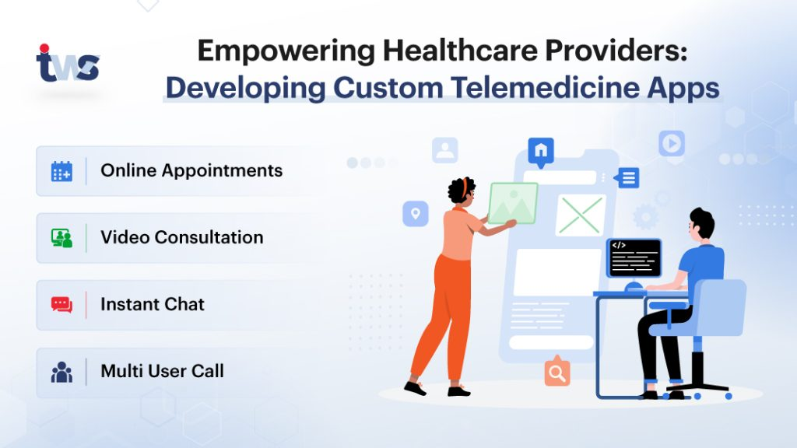

Figure : Uses of Telemedicine

Source: (Karan, 2023)

Telemedicine can enhance the patient-physician bond that exists between the two parties. Teleconsultations do not necessarily require a formal approach as physical ones, which contributes to enhancing patients’ trust. It is convenient for the patient to contact his or her healthcare provider for queries or any issues, thereby making healthcare more anticipatory as compared to the past. Moreover, the use of telemedicine can increase the involvement of the patients. Digital platforms can educate patients, remind them of their next appointment, and contribute to monitoring their health status (Abdel-Wahab et al., 2020). Such characteristics help patients to become more aware of their health which helps in adhering to the treatment plans, maintaining well-being, and enhancing the outcomes of health. Furthermore, telemedicine provides several benefits to the patients like scheduling consultations at their convenience and discussing issues with physicians virtually. This flexibility is specifically beneficial for people with chronic conditions requiring routine check-ups and those needing immediate suggestions for acute issues.

The traditional healthcare model generally involves patients visiting health facilities for consultations and to purchase prescribed medicines or equipment. This approach poses various challenges like inconvenience due to transport, long waiting hours, and lack of healthcare professionals in remote areas. However, these challenges can be addressed by telemedicine, as this practice involves consulting the patients remotely which helps to consult doctors by sitting at home. While advanced technology has already been integrated into the system, the healthcare e-shop offers personalized healthcare products required by the customer. Such integration offers a one-stop shop where patients can discuss with healthcare providers and purchase the required medicine or equipment. The e-shop can provide personalized recommendations based on the patient’s information thereby ensuring to improve the overall healthcare experience.

Technological frameworks for developing this project are Python for the backend, React JS in the front end, and MongoDB for managing the database. Some of these technologies guarantee a solid and flexibly developed platform with a high number of users. Therefore, continuous feedback and an iterative approach, which is supported by agile project management will help in making continuous improvements (DIAS, 2021). With the increased technological evolution, the healthcare industry is evolving rapidly through the transformed medical services. Conventional healthcare systems often face issues or challenges related to poor convenience and accessibility, particularly in underserved and remote areas. Therefore, this research focuses on bridging this gap by developing an advanced Online Telemedicine Marketplace and Personalized healthcare e-shop, a web portal to let customers easily access various healthcare services (Al Meslamani et al., 2020). The user can conveniently schedule virtual consultations with doctors or healthcare professionals, and purchase medicines, and other healthcare products online. This research will optimize user accessibility to healthcare services by integrating E-commerce capabilities with telemedicine services and personalized healthcare solutions as per individual requirements.

Python will mostly be applied in the backend since it is solid and can handle complex applications. Due to its well-developed libraries and frameworks, the integration of functionalities and quick development of applications are possible in Python, and thus, the backend operation is seamless (Dao Ngoc Phuong, 2021). React JS shall be used in the development of the front end as it has qualities such as the ability to create an enhanced user-friendly interface. Recognized for its performance and ability to scale well, React JS is particularly well-suited for applications that would be dealing with many users at the same time. Moreover, it has a component-based approach that removes the difficulties in the creation of UI components further helping in development speed and quality (Manita, 2024). For this platform, MongoDB will be used as the database of the platform. Clear examples of the benefits of MongoDB are the use of NoSQL which allows indexing different types of data written in different formats. This is relevant for a telemedicine platform that is required to work with a variety of information such as product inventories, user data, and consultation records.

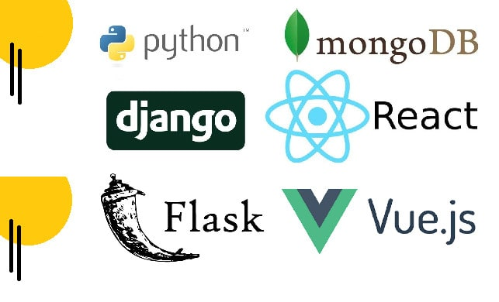

Figure : Web Development Software

Source: (Fiverr, 2024)

The research is being motivated by various key factors that have been mentioned below:

* **Increased Demand for Remote Healthcare:** The outbreak of COVID-19 brought out the efficiency of remote solutions in the health sector. Patients have embraced virtual consultations to a large extent since it is safer and more convenient as compared to physical consultations.
* **Accessibility Issues:** Poor and rural clients do not easily get quality healthcare services. Telemedicine provides a solution by providing access to health professionals in various geographic locations.
* **Technological Advancements:** Recent advances in web technologies and other digital tools have facilitated the possibility of designing user-friendly and highly efficient telemedicine environments (Haleem et al., 2021). The opportunity to use these technologies can be very beneficial in improving the process of healthcare service delivery.
* **Personalized Healthcare:** The individuality of treatment and healthcare products, therefore, continues to rise as a trend that is currently popular. Besides, it is applicable in creating a healthy environment that increases the rate of patients’ recovery and satisfaction.
* **Convenience:** It cannot be denied that patients appreciate the absolute comfort of being able to get advice from a healthcare professional as well as to buy the necessary medical products without leaving their homes. This is especially helpful for people who have some form of disability that affects their ability to move around.

This research is an attempt to develop a complete teleconsultation service through which it also incorporates an e-shop for healthcare products. In this way, it mitigates the drawbacks of current healthcare systems and offers a more effective, convenient, and cost-effective service to the patients.

## Problem Statement

The traditional healthcare model has several problems concerning approach, availability, and affordability with special reference to underserved and remote regions. A challenge the patients face is that they are unable to arrange consultations at convenient times and access significant medical products. COVID-19 has worsened these challenges further thereby ensuring to realize importance of virtual healthcare solutions. Thus, the existing gap in the market is the lack of connection between teleconsultation services and personalized healthcare product recommendations. This research intends to overcome these challenges by creating an Online Telemedicine Marketplace and Personalized Healthcare E-shop that will combine all necessary services. This will assist to facilitate the process of receiving proper healthcare services and optimize it according to the patient’s preferences.

## Aim and Objectives

### Aim

This research mainly aims to develop a web portal for users or patients to book consultations with healthcare professionals virtually and purchase personalized medicine and other healthcare products online.

### Objectives

* To analyze the role of Python and ReactJS for backend, and frontend development to create a responsive platform.
* To integrate Mongo Database to store the records of consultation, data of the users, and information regarding healthcare products.
* To offer feasible solutions for increasing access to products, and healthcare services to patients in remote areas.
* To examine the role of healthcare professionals in the online telemedicine marketplace and delivering personalized healthcare services to patients.
* To assess the role of online telemedicine marketplace and personalized healthcare e-shop in providing satisfaction to patients.

## Summary of Project Plan

The research involves several essential steps to support the development and application of the Online Telemedicine Marketplace and Personalized Healthcare E-shop. The first phase involves requirement identification and assessment to establish concerns and understanding of the preferences of the target clients. The relevant research papers and journal articles are selected and reviewed to gain a better understanding of this research and gain useful research insights. The next stage is the design and development phase, in which the web portal shall be developed where the backend operations will be done using Python and the Front-end operations using React JS. MongoDB will be incorporated since it is suitable for data storage and management (Fiverr, 2024). Agile project management methods will be used to encourage a working algorithm approach. After the prototypes of the system have been created functional, security, and scale tests of the system will be conducted. This includes stability tests such as load testing where the platform should be tested to accommodate several users at a time and security tests to safeguard patients’ information. After the testing phase is completed, the pilot phase comes next whereby a limited number of users have the advantage of using the system. Information gathered from this phase will be important in making changes. The last one consists of the full cross-platform implementation followed by updates and maintenance. Data collection will be another source of information through which the reactions of the users to the developed platform will be collected to make sure that changes are made in response to the needs of the patients and other healthcare providers (Cohen et al., 2020). Overall, the research aims to create a stable, easily extensible network that will improve the general availability of healthcare services. This will help to offer virtual consultation, and highly personalized healthcare products to the patients at their ease.

## Approach Adopted

This research uses a mixed-methods approach including quantitative, and qualitative methods which helps to collect useful information. By applying such an approach, the results of the current study are highly valuable in developing the Online Telemedicine Marketplace and the Personalized Healthcare E-shop (Dawadi, Shrestha & Giri, 2021). This helps to understand the preferences of the patients thereby ensuring to enhance the level of satisfaction.

Quantitative methods include the use of reputable academic articles, government publications, and industry reports from healthcare providers and organizations. It will facilitate collecting numeric data based on the preferences of the users, the level of satisfaction with existing telemedicine services, and the frequency of use. Statistical analysis will be conducted that assists in identifying patterns and trends to provide a solid quantitative foundation for the research. However, qualitative methods including peer-reviewed articles, books, journals, reports, and focus group discussions shall be used to obtain data (Wallwey & Kajfez, 2023). The healthcare professionals will give their insights into the realities of the implementation of telemedicine. Patients and clients in the form of focus groups will help to identify and discuss the patient’s perception regarding virtual consultation and buying online healthcare products.

The mixed-methods approach is especially beneficial for this investigation as it involves the use of different instruments based on the paradigms of research in which cross-checking or validation also known as triangulation is possible (Fetters & Tajima, 2022). It also provides an understanding of the research problem under consideration from different views which is very important while implementing a user-friendly and efficient telemedicine platform. The above process shows that through the integration of quantitative and qualitative data, the approach enables the implementation of a reliable and diverse development for the telemedicine platform and e-shop thereby ensuring to provide an effective and appropriate solution.

## Ethical issues

Some of the major concerns in this research shall be focused on ethical issues so that every participant’s rights, identity, and safety are protected. The ethical concerns are consent, privacy, and anonymity.

* **Informed consent**: The patients should be aware of the implications of the provided services by this application and they are aware of how this data will be utilized and who might access this data. An informed consent should be taken from all participants before collecting any data from the patients and providing any services.
* **Data security and privacy**: This online telemedicine app will manage the sensitive information related to the patient’s medical history, prescriptions, medicines, and consultation details. So it will be necessary to protect this data or information from any data breaches, misuse, and unauthorized access.
* **Equitable access**: This proposed telemedicine app can only be used on digital devices and needs an internet connection. So it may pose disparities in providing equal access to patients who have limited access to digital devices and internet access.
* **Quality of patient care**: This proposed telemedicine platform must ensure that all the healthcare professionals meet the desired qualifications and standards and are well-experienced in their respective fields to ensure that the provided consultation services are compatible with the in-person consultation services.

## Dissertation structure

* **Introduction:** This chapter gives a clear understanding of the research topic by detailing the justification for the study, background to the study, problem statement, research aim, and objectives. This section will therefore provide the background to the study and establish the need for conducting the research.
* **Literature Review:** This chapter will provide a literature review of related works on the concept of telemedicine, telecare, personalized healthcare e-shops, and their integration. The paper will reveal the gaps in the existing literature and establish the theoretical framework that will guide the research.
* **Methodology:** This chapter will outline the research method like the mixed approach in conducting the research, data collection tools, and analysis approaches. It will justify the chosen methods and explain how they will meet the objectives of the research.
* **Requirements and Design:** This chapter will set down the conditions that should be met by the telemedicine marketplace and personalized healthcare e-shop. It will also contain the design of the proposed model comprising the system architecture, features, and functionalities.
* **Solution Implementation:** This chapter will outline the process of the theoretical model that has been proposed in this research. It will also include the considerations implemented with any difficulties experienced in the implementation mentioned and the solutions adopted.
* **Solution Evaluation:** This chapter will critically discuss the outcomes of the studies conducted with the use of the proposed model through simulations, pilot studies, and analyzing data. It will argue or demonstrate the practical applicability, effectiveness, and changes to implement the model in the healthcare system.
* **Critical Evaluation:** This chapter will therefore present the implications of the research findings, its limitations, and the contribution of the study to the existing literature. It will comment on the procedure that has been followed for its research and will make recommendations for subsequent investigations.
* **Conclusion and Future Work:** Finally, the conclusions will be made and the recommendations for future research and practice will be specified. They will identify possible consequences of implementing the proposed model on the delivery of healthcare services.

Figure : Dissertation Strucutre

Source: (Created by author)

# Literature Review

The literature review is one of the significant sections of the study as it sets the current research within the context of the prior studies. It is used to determine the existing gaps, findings, and developments of prior research (Paul & Criado, 2020). In the context of this research, the literature review will focus on outlining the key themes concerning online telemedicine marketplaces and personalized healthcare e-shops. Telemedicine is a suitable example of how modern technologies have brought advanced ideas and have become a necessity with the COVID-19 outbreak. At the same time, personalized healthcare is associated with the use of digital health solutions and catering to the demand of consumers for tailored healthcare products (Colbert, Venegas-Vera & Lerma, 2020). This helps in transforming the traditional models of delivering healthcare services. Hence, through a systematic integration of findings from various literature sources, the nature and requirements of the current state and issues essential for future study will be outlined. Overall, this literature review will form the necessary background for the subsequent investigation and analysis of this study thereby ensuring to provide a robust academic foundation for this research.

## Role of Emerging Technologies in Healthcare and Applications

According to Seetharam et al., (2019), technological advancements largely impacted today’s healthcare system by providing many automated devices while increasing the information sharing capabilities among the users globally. The intersection of higher-capabilities computing devices and digital technologies led toward a revolution in healthcare industry and facilitate mobile health (mHealth) and telemedicine. However, the immense data influx from mHealth and telemedicine cannot be handled by the existing healthcare systems. The integration of machine learning (ML) and artificial intelligence (AI) can only navigate this huge maze of data influx. Further, deep learning (DL) method significantly expand the process of image detection and precise measurement. The evolution of AI realized immense opportunities for rigorously analyzing the healthcare data.

Sharma et al., (2023)aruges that the intgeraton of AI with telemedicine has immense potential of improving an expanding the capabilities of telemedicine to address various healthca needs, such as intelligent diagnosis, patient monitoring, healthcare information technology, and real-time assistance. AI assists the healthcare professionals in improving healthcare deliver, decision-making abilities, and automated administrative tasks. To further improve the effectiveness, AI-empowered telemedicine needs to comply with the existing clinical processes and adhere to the adaptable framework with various digital technologies.

## Python and Django in Responsive Web Development

Many programming languages and frameworks are there that can be used in the development of the proposed software application Online Telemedicine Marketplace and Personalized Healthcare e-Shop. Java is the most comprehensively used backend programming language and can develop robust cross-platform applications. It is comprehensively used in the development of websites, servers, games, scientific apps, and embedded space (Research, 2022). PHP is another popular programming language mainly used to develop dynamic websites and applications. Python is the most admired programming language among developers and can be easily integrated with C and C++. Further, Kotlin is also used to develop Android applications that can support all IDEs, including the SDK toolkit and Android Studio. It is easy to learn and use due to its perceptive and concise syntax. Further, there are several frameworks, such as Node.js, .Net, and Angular that can be used with these programming languages to develop robust websites and software applications. Node.js is a highly scalable and single-threaded framework and offers the ability to use JavaScript. On the other hand, .Net is a cross-platform that enables to building of diverse software applications (Horiachko, 2023). Angular is mainly used to develop high-performing and extremely scalable web applications with highly user-friendly interfaces. Django is another popular and high-level framework that mainly facilitates high-level development and pragmatic design of software applications.

Gourav (2024), Python is particularly famous for its easy-to-understand coding style that is so appropriate in back-end development. It drives growth and also provides the integration of various systems at a very fast rate. Python has various frameworks including Django and Flask that help in the construction of highly scalable and resilient web applications. Python is a programming language that can be used in several domains such as Web development applications, and data science applications. For example, Django is a high-level Python web framework that supports concepts such as rapid development and a clean, practical style. It includes various in-built features such as authentication and database management, and reduces the number of code developers need to write. Therefore, this assists in reducing the risks of errors and ensuring improved productivity. On the other hand, according to Nisarg (2022), React is a JavaScript library that helps in creating interfaces and user interfaces specifically for single-page applications that must be responsive and involve the manipulation of components. ReactJS was developed by Facebook and the result has been outstanding because of its efficiency and flexibility. However, through its virtual DOM ReactJS efficiently performs the services suitable for applications with dynamic user interfaces​. Its component base architecture is impressive which makes it easy to maintain and reuse components. This modularity is good when developing big applications as it makes the debugging process easy thereby ensuring enhanced scalability of the code. Another major strength of ReactJS is that it can be used with almost any backend technology. Due to its compatibility with Python backend, it is suitable for frontend development. This also means that understanding how to utilize hooks and context APIs helps to provide a smooth experience to the user in data-intensive applications.

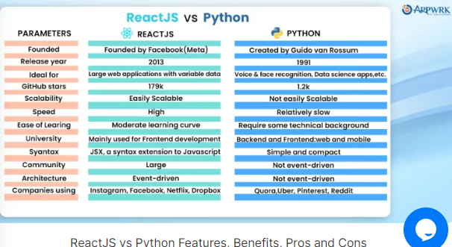

Figure : React vs Python Features, Benefits, Pros and Cons

Source: (Gourav, 2024)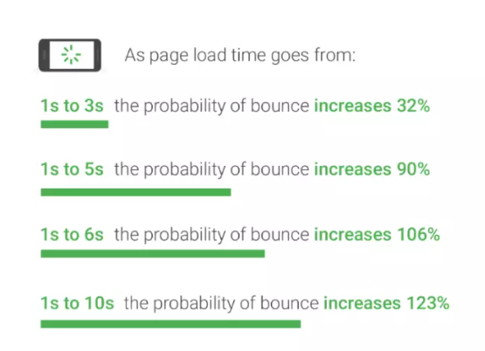

Figure : Page Load Time

Source: (Gourav, 2024)

## MongoDB Database to store Healthcare Data and Consultation Records

In the words of Alexander (2024), MongoDB features such as schema-less enable to change of the structure of the database as the healthcare platform expands. This flexibility is crucial to accommodate new forms of data into the architecture of healthcare services as the services offered change. For example, MongoDB can manage highly developed forms of data like medical images, structured patient data, and product inventories simultaneously in the same database. However, as mentioned by Geeks for Geeks (2023), another feature of MongoDB that is important is scalability. That can horizontally be scaled across multiple servers which means that as the number of users and the amount of data increases the database can handle the load efficiently. This is significant for healthcare platforms where it experiences a rapidly increasing volume of users’ data and transaction records. The feature to scale out by adding more nodes to the cluster ensures uninterrupted services and maintains actual performance.

According to Geeks for Geeks (2023), Some of the key features of MongoDB include indexing, replication, and sharding which help to improve the performance. Indexing ensures efficient query response which should be desirable when consulting, searching for patient records, or a specific product. Replication helps in data duplication, thereby making sure that the records are always available hence fulfilling the high availability and disaster recovery requirements in health facilities. Sharding again refers to dividing the data across multiple servers where the large data is partitioned into small portions. However, as mentioned by Alexander (2024), in healthcare applications, security remains a significant factor of consideration owing to the information contained in an individual’s personal health information. MongoDB provides robust security features like encryption both at rest and in transit, RBAC, and auditing. These features assist in providing adequate security to the patient data to avoid unauthorized access and data breaches as required in the healthcare industry concerning HIPAA. Encryption makes it impossible to use intercepted information since it can only be decoded by the decryption key thereby maintaining the privacy of the patients.

Alexander (2024), states that the extent to which MongoDB is in demand and supported by the community tends to underscore its efficiency and reliability. Currently, the number of MongoDB users stands at millions and this number is still rising which shows that it has a very strong database and many experts trust it. Also, the capability of the database to manage large amounts of information is evidenced by numerous applications. This proves its ability to support healthcare platforms with high data traffic demands. However, in the words of Geeks and Geeks (2023), from the perspective of development, the underlying model of storing documents in the cases of MongoDB is more suitable for modern programming which makes development quicker and more efficient. This is especially helpful for healthcare platforms which require timely updates regarding features and functions to cater to the users and the rules and regulations set by the market, and government. The incorporation of MongoDB into healthcare applications will greatly scale down the time taken to launch the applications since the incorporation of MongoDB has made data modeling relatively easy and has reduced the complications that are usually provided by relational databases.

## Increasing Remote Access to Healthcare Products and Services for Patients

Barbosa et al. (2021), stated that Telemedicine and digital health technologies play a crucial role in addressing various challenges. Hence, these technologies can be used to offer consultations, diagnoses, and treatment without the necessity for long-distance travel by the patients. Telemedicine has grown rapidly in recent years for example, it has expanded by 154% during the COVID-19 pandemic illustrating the use and efficacy. A pilot program in rural areas of India has shown that the use of telemedicine consultations resulted in a remarkable 50% reduction in the patient’s travel time and costs making healthcare services accessible in remote areas. Furthermore, telemedicine has provided an opportunity for constant treatment of chronic illnesses, mental health disorders, and follow-up consultations thus reducing the time that patients receive appropriate treatment. On the other hand, as mentioned by Omboni et al. (2022), another efficient solution to extend access to healthcare is mobile health clinics. These clinics include diagnostic tools, medicines, and telecommunication facilities to the target areas and offer necessary medical services. The NCBI suggests that a study done on the effectiveness of mobile health clinics was able to access 87% of the targeted remote populations by providing services like vaccination, maternal, and child health care, and managing other chronic conditions. These mobile units are not only involved in the effective and efficient provision of healthcare services but are also significant in educating the population on common illnesses and how to prevent them thereby enhancing the health of the nation.

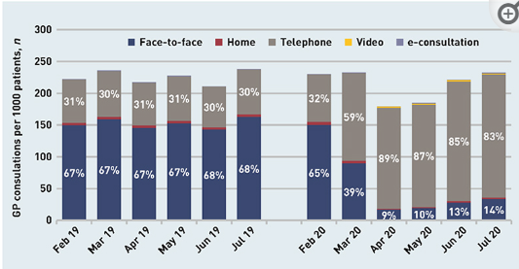

Figure : General practitioners' consultations

Source: (Omboni et al., 2022)

In the words of Barbosa et al. (2021), engaging Community Health Workers (CHWs) is one of the effective strategies that seeks to ensure that healthcare services are expanded within remote areas. CHWs have been provided training on health education and delivering basic medical care to prevent disease. Applying the information derived from the Annual Review of Public Health it is possible to conclude that its programs for CHWs can contribute toward a 25% decrease in child mortality in the rural areas of Sub-Saharan Africa. Therefore, by collaborating with CHWs, healthcare systems increase the extent to which health facilities can interface with clients, and remain a reliable source of quality service for vulnerable populations. Furthermore, CHW programs benefit the local communities by providing job opportunities and fostering the involvement of community members in health initiatives. However, in the words of Omboni et al. (2022), public-private partnerships (PPPs) are crucial in raising funds and acquisition of human capital which will play a pivotal role in developing health facilities in remote regions. Such partnerships might result in the creation of new health facilities, efficient ways of delivering health products, and generally improved healthcare services. For example, in Kenya, Public-Private-Partnerships has experienced a success story in the healthcare delivery system where it has enhanced the construction of clinics and training programs for the staff with an improvement of 40% in healthcare delivery systems. However, such partnerships utilize the strengths of both public and private sectors thereby fostering innovation and enhancing efficiency.

## Healthcare Professionals to deliver Personalized Healthcare Services through Telemedicine

As stated by Antonacci et al. (2023), Telemedicine enables healthcare professionals like doctors, nurses, and specialists to provide consultation, diagnosis, and follow-up via technology. It has also clearly established that there has been a paradigm change in the use of telemedicine as more volumes of research reveal an increase in the use of telemedicine solutions. For example, the National Institute for Health Care of Italy found that the number of teleconsultations increased by 40% in 2022 because the care was delivered continuously during the pandemic. However, as stated by Shweta (2024), Telemedicine helps in monitoring and making adjustments to treatment plans depending on the real-time information. This is very useful in chronic diseases where ongoing adjustments are very significant. Research has demonstrated that telemedicine enhances chronic illness care and saw a 30% improvement in managing diabetes by monitoring and providing consultations remotely. Telemedicine is revolutionizing how chronic diseases are controlled. Through telemedicine patients having problems like diabetes, hypertension, and asthma save a lot of time and money to seek the health care services frequently. However, the conditions of patients are monitored constantly from a distance any deviations can be identified in time, and management strategies modified accordingly. Implementing this approach drastically decreases the potential of adverse effects, re-admissions, and emergency room visits which increases the general well-being and happiness among the patients.

In the words of Antonacci et al. (2023), telemedicine helps in educating and enhancing the involvement of the patients. Patients get the opportunity to access relevant educational material, interact with other patients, and communicate with physicians. Such accessibility allows patients to be much more proactive in maintaining their health which in turn increases chances of success in compliance with healthcare professionals’ recommendations and therapeutic plans. The convenience of having direct access to the provider also tends to ensure that patient’s concerns are adequately addressed and this results in the improvement of their satisfaction with the healthcare system. The integration of telemedicine also solves several logistical problems. For example, clients from rural areas experience substantial challenges in receiving proper treatment. Telemedicine helps to overcome this problem since the patients will be able to consult with specialists without traveling long distances with stretched resources. This availability is especially helpful for immobile patients or people who frequently need to consult with a doctor. Furthermore, as influenced by Shewta (2024), it is statistically proven that telemedicine is cost-effective for patients and healthcare professionals. To healthcare providers, telemedicine presents a way of cutting down on the operational expenses attributable to establishing fixed physical offices and it can help to enhance the efficiency of appointments thereby serving more patients. It is accompanied by technological limitations including the stability of the internet connection and proper expertise of Information Technology by patients and even the healthcare professionals. Ensuring the security and privacy of data helps to develop trust and compliance with various other regulatory standards. However, due to the emerging nature of this practice, there is a lack of a standard set of protocols and procedures that should regulate the application of telemedicine and the quality of services provided.

According to Antonacci et al. (2023), The staff and the doctors had to adapt to new changes, especially to new technology and workflow. The telemedicine tools’ integration led to healthcare professionals’ expertise in working with digital solutions and guaranteeing the highest level of patient care provision from a distance. A survey revealed that 70% of healthcare practitioners said that the use of telemedicine technology enhanced their productivity in taking care of patients. However, as mentioned by Shewta (2024), Telemedicine improves and enhances the interaction between the patient and the healthcare provider. Patients are more likely to adhere to the treatment plans when they get the opportunity to interact with the healthcare provider. A study noted that 95% of the patients who received telemedicine services were satisfied with the service, and 85% of patients said it made them more engaged in their treatment. The integration of telemedicine with electronic health records and various other advanced digital tools enables healthcare professionals to make effective decisions. Therefore, analyzing the patient data comprehensively helps in providing personalized care and treatment. It was identified that utilizing EHR-integrated telemedicine platforms enhanced 35% of clinical decisions.

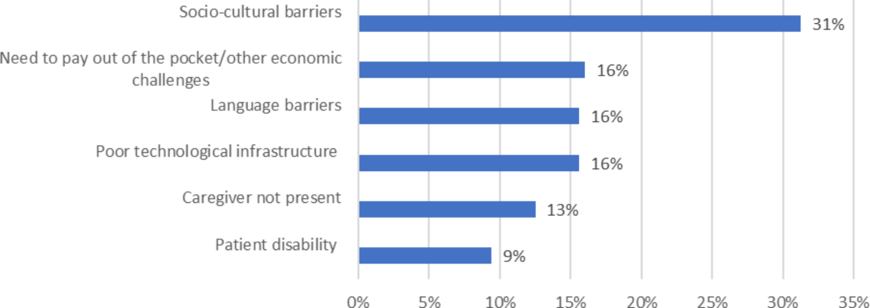

Figure : Barriers to the use of telemedicine for specific groups of patients

Source: (Antonacci et al., 2023)

## Online Telemedicine and Personalized Healthcare e-Shop Marketplace

In the words of Ramaswamy et al. (2020), One of the significant advantages of telemedicine is convenience. People especially those in remote areas that have inadequate access to healthcare facilities have described telemedicine as an invaluable service that helps to bridge the gap in healthcare delivery. For example, a rapid increase in online visits, of 8729% at an academic medical center, 4345% at New York University Langone Health, and 4000% at Partners Healthcare show the impact of telemedicine during the pandemic. This demonstrates the urgent requirement for patients to have access to healthcare services during the pandemic. However, in the words of Alashek & Ali (2024), despite various benefits, several challenges must be addressed to maximize the satisfaction of the patients. Some limitations for patients in using telemedicine services include technological issues like the challenge of configuring the telecommunication programs and equipment. Measures for helping patients facing technical problems are crucial for enhancing the general level of satisfaction​. Also, the social determinants of care for example, in the management of elderly patients or patients with hearing impairments while engaging in telemedicine services have to be taken into consideration.

According to Ramaswamy et al. (2020), patient satisfaction is a crucial measure of the success of telemedicine. For example, Hoff and Lee conducted a systematic review in which it concluded that specialists’ satisfaction was high irrespective of their locations and specialties. Furthermore, convenience and ease of use received much appreciation as 92 percent of patients at a Texas neurosurgical center pointed out that their telemedicine clinics are satisfactory, and 88 percent of those who were interviewed preferred telemedicine thereby considering it convenient​. A personalized healthcare e-shop is another feature that assists in enhancing satisfaction among patients. Such platforms deliver personalized healthcare goods and services so that consumers acquire suitable and particular medical solutions. The effective use of digital health tools like personalized healthcare e-shops helps in improving the overall healthcare experience of the patients. However, as mentioned by Alashek & Ali (2024), personalized healthcare e-shops contain new technologies including artificial intelligence and data analysis solutions to provide relevant suggestions concerning patients' medical records and preferences. It not only increases the efficiency and significance of the products provided but also creates the feeling of individual approach among patients. Moreover, the availability and accessibility of the delivery of healthcare products increase patient satisfaction, especially for those with restricted mobility or diseases that require frequent supplies of compounds. In addition, they offer additional tools such as teleconsultation with doctors which increases the patients’ access to prompt consultations. Therefore, it becomes an alternative to face-to-face visits when there is a need for urgent medical advice. This concept of care delivery makes certain patients get appropriate, continuous, and complete care thereby improving their healthcare experience.

As stated by Ramaswamy et al. (2020), studies have indicated that telemedicine is as good as normal in-person visits in terms of efficacy there are no disparities in clinical results. But, the costs as well as the satisfaction of the patients are normally higher in telemedicine. For example, clinical consultations conducted with the help of online visits tend to be associated with providing a high level of satisfaction to the patients. This results in reducing the costs without compromising the clinical results​. This is especially quite essential for the different chronic disease patients who need frequent check-ups and follow-ups. However, according to Alashek and Ali (2024), the shift toward telemedicine and personalized healthcare e-shops demonstrates transformation in the healthcare industry. This transformation helps in maintaining the protocols of social distancing and provides appropriate care to the patients during the COVID-19 pandemic. This highlights the effectiveness of digital healthcare solutions which help cater to the needs of patients thereby ensuring to provide them satisfaction and enhance well-being.

## Research Gap

However, the existing research addresses the impact of digital technologies in the healthcare sector but somewhere they fail to justify the impact of these technologies in improving functionality and user experience. The existing research also did not provide a detailed investigation of Python and Django on better handling large healthcare data volumes to offer a seamless user service experience. There is a need for further research to demonstrate the effectiveness of the MongoDB database in enhancing the scalability, security, and compliance aspects with better healthcare data management. The existing research addressed the importance of remote access in the healthcare industry but there is little research to address the best strategies for improving remote access via personalized e-shops and telemedicine marketplace. The existing research posed limited focus on the role of healthcare professionals to deliver personalized healthcare services through telemedicine, in terms of patient interaction and training. There is scarce research on addressing the implications and best business models for the telemedicine marketplace and personalized healthcare services.

## Summary

The existing literature review describes the shift in the focus of the new healthcare management tools after COVID-19 including online telemedicine marketplaces and individualized healthcare e-shops to transform the healthcare industry. Python is a significant technology for backend development and at the same time, ReactJS is also pointed as a key for frontend development for making responsive and scalable platforms. Django helps in quick, bug-free development while React JS is more modern and is based on the components best suited for interfaces that need to be responsive. Specifically, MongoDB offers a free form and a highly scalable structure of the database that can accommodate various healthcare data types and secure their efficient management. Based on the results presented in this research, it would be possible to conclude that telemedicine provides efficient possibilities for expanding access to healthcare services and reducing travel expenses. Furthermore, mobile health clinics and Community Health Workers play a crucial role in providing healthcare services in remote areas. Healthcare professionals use telemedicine for consultations, and monitoring patients with chronic diseases. Telemedicine combined with electronic health records improves clinical decision-making, yet technical and legal factors continue to be significant challenges. However, there are arguments that much research is still needed to provide a better understanding of the use of technology in teaching and learning processes because the following issues have not been sufficiently investigated yet. It includes the long-term effectiveness, addressing the digital divide, financial implications, and the ethical manner in which data is being managed while conducting of research.

# Methodology

The methodology represents another important part of this research as it will outline the employed research design, procedures, and methods for achieving the research aim and objectives. It will provide a comprehensive discussion of the taken steps for gathering, analyzing, and interpreting the research. It helps ensure that the research is systematically conducted with high rigor while providing transparency to the readers regarding how the research results are derived. This chapter will first provide an overview of the adopted research design with the rationale (Editorial Team, 2024). Then it will provide a description of the methodology, including research philosophy, research approach, research strategy, data collection methods, and data analysis methods. Further, it will discuss the tools and techniques with the used software tools. Finally, it will address the associated ethical considerations with this research.

## Methodology description

This section provides a detailed discussion of the adopted methodology to examine the need for an online telemedicine marketplace and personalized healthcare e-shop using secondary research data. The secondary research includes a detailed analysis of the existing data gathered and used by other authors, which is a time-efficient and cost-effective method.

### Research design

This research study follows a descriptive and exploratory research design to provide a better understanding of the need to facilitate optimized healthcare services personalized as per the patient’s specific needs and preferences (Aggarwal, 2024). This research design is centered around the collection and analysis of secondary research data by leveraging available information from existing research papers or journal articles to draw meaningful insights.

#### Rationale

The use of an integrated descriptive and exploratory research design offers a comprehensive strategy to develop the online telemedicine marketplace and tailored healthcare e-shop. The descriptive research design will provide a robust foundation to better understand the current landscape of telemedicine and personalized healthcare using quantitative data based on user demographics, service types, and usage patterns. The exploratory research designs can let deep delve into the user’s preferences, experiences, and unmet needs while uncovering critical insights that could not be captured using quantitative data alone. Also, this research design can also help in ensuring a thorough investigation to realize a well-organized understanding of the telemedicine market following existing trends and data driven by user needs and expectations.

### Research Methodology

This research study will use a mixed-research methodology, which includes a quantitative and qualitative research methodology to realize the vital insights of both of these methods to analyze the previously published research data (Team, 2023). This research methodology will provide a detailed understanding of this research topic by integrating the numerical data with the contextual analysis.

#### Rationale

The use of mixed research methodology can provide an effective, nuanced, and reliable understanding of this research topic by integrating the vital insights obtained from both qualitative and quantitative methods. This research methodology is particularly important in the development of an online telemedicine marketplace and tailoring healthcare E-shop to deal with the intricate nature of this research. This research methodology can realize the comprehensive perspectives from the usage patterns and accessibility extent related to telemedicine along with including the user preferences, faced issues, and experiences (SCAND, 2024). Also, it can better validate the reliability of the obtained research findings to ultimately ensure that the developed telemedicine marketplace and personalized healthcare E-shop are highly data-driven and consumer-centric.

### Research Philosophy

I use a pragmatism research philosophy to guide this research study. This research philosophy mainly focuses on the practical applications of the obtained research values and findings, including both subjective and objective knowledge (Kaushik & Walsh, 2019). It is most appropriate for this research to study the need to bridge the gap in the healthcare industry related to the lack of integration between personalized healthcare services and teleconsultation services due to its ability to accommodate diverse perspectives and methods for addressing real-world problems faced by patients while taking healthcare services.

#### Ontology

Ontology represents the nature of reality and what is known about this. This research study adopted a constructivist ontology, which hypothesizes that reality is context-dependent and socially constructed. It is well aligned with the main focus of this research to fill the gap between online consultation services and personalized healthcare products for better accommodating the specific needs of the patients.

#### Epistemology

Epistemology mainly deals with the nature of available knowledge about the research and how it has been obtained and validated. This research study used an interpretivist epistemology, which highlights the significance of individual experiences and meanings within specific research contexts. It will help in realizing the interpretations of industry reports, existing research, and case studies with a key focus on the secondary research data for extracting relevant and vital insights to inform the development of telemedicine and personalized healthcare E-shop.

#### Rationale

The selected pragmatism research philosophy mainly focuses on the real-world applications of the used methods and obtained research findings that can better address the research questions. It is especially appropriate for this research that intends to resolve the real-world issues faced by the patients in taking assistance and medicine as per their specific health needs and conditions (Kaushik & Walsh, 2019). It is suitable to utilize both quantitative and qualitative methodologies while emphasizing the practical implications of the results of this research. Also, it is specifically focused on addressing the practical issues that make it an ideal choice for this research for improving healthcare availability, affordability, and accessibility. Further, the use of constructivist ontology facilitated user-centered perspectives and adaptive design for the developed web portal. Moreover, interpretivist epistemology can provide contextual insights and better understanding by supporting the qualitative methods to realize richer research insights.

### Research strategy

This research strategy includes a systematic review strategy of the secondary research data. It comprises:

* **Literature review**: This research first conducts a thorough review of the relevant and previously published academic papers, articles, case studies, and industry reports based on the addressed research problem, used methods, theories, or concepts, proposed solutions, and limitations to gain a better understanding of this research topic.
* **Data synthesis**: Then it analyzes and synthesizes the obtained data from diverse sources for identifying the key findings, patterns, themes, and trends within this research field.
* **Comparative analysis**: Then the obtained findings are compared across diverse research studies for a better understanding of the addressed diverse viewpoints and common themes or patterns.

#### Rationale

The selected systematic review research strategy can help in ensuring a methodical and rigorous approach to this research for improving the validity and consistency of the research findings through a wider coverage of the existing literature. It also facilitates efficiency by reducing the time needed for data collection from secondary research data. Further, it can also help produce important and actionable insights through the comparison and synthesis of existing research studies. Overall, this research efficiently leverages the available knowledge in existing studies along with identifying the gaps, trends, and patterns to realize the most actionable and robust research insights to ultimately advance this research field.

### Research Approach

This research used an abductive research approach, which combination of both inductive and deductive research approaches (Conaty, 2021). Using the deductive research approach, this research analyzes the existing frameworks and theories related to the need of patients for telemedicine and personalized healthcare services to guide the process of data collection and data analysis. Then this research will utilize an inductive research approach to develop novel theories and insights following the emerging themes and patterns from the conducted data analysis.

#### Rationale

The abductive research approach mainly emphasizes productive new theories and hypotheses via an iterative procedure to observe the underlying research phenomena, recognize vital patterns, and realize explanations. This approach is suitable for this project because it can efficiently design, test, and refine the developed web platform considering real-world interactions and user feedback. Also, it can facilitate the development of novel theoretical insights following practical observations. Also, it well aligns with the selected mixed research methodology for realizing flexible data collection and analysis methods while adopting emerging research insights. Further, it can efficiently support an in-depth understanding of user requirements and behaviors along with personalization and customization as per the user feedback.

## Data Collection

In this research, I was collected the desired research data from the relevant and previously published research papers, journal articles, industry reports, and case studies from reputable journals, such as Google Scholar, IEEE Xplore, Science Direct, Springer Link, etc. These sources are selected following the relevance to the research problem, used methodologies, and research quality. The relevant articles were selected following the key search terms, such as telemedicine, personalized healthcare, online healthcare marketplace, and web development technologies (Cheong et al., 2023). I have extracted key information from all the chosen sources, including the data related to the technological solutions, healthcare market needs, user issues, needs, and preferences in e-healthcare and telemedicine services. Then this extracted data is organized in a well-structured format to facilitate easier access and analysis.

## Data Analysis

For the analysis of collected research data, I used statistical analysis and thematic analysis methods. The extracted main features and insights from the collected data are described and summarized for a better understanding of the frequency distribution, central tendency measures, and dispersion measures. Further, the associated inconsistencies, gaps, or contradictions are highlighted. A detailed thematic analysis is conducted to recognize the recurring trends, patterns, and themes with the gathered secondary research data (Caulfield, 2023). It includes the data coding, grouping of similar data codes into specific themes, and interpretation of the importance of research themes related to the research objectives. The research themes are mainly based on the existing market gaps, user needs & preferences, challenges in e-healthcare services & telemedicine, and technological solutions.

## Software Tools

### Development tools

* **Code editor**: **Visual Studio Code** represents one of the most powerful and lightweight code editors that can efficiently support multiple development tools and programming languages. It is a very popular and most frequently used code editor by developers due to many reasons, such as its extensions, ease of use, collaboration, and an integrated terminal (Lamb, 2023).
* **Version control system**: I used **Git**, which represents a distributed version control system to track the source code changes in real time throughout the entire process of software development. It is very important for collaborative or group projects. It provided many benefits, such as version tracking & controlling and seamless collaboration.

### Front-end development

* **React with Vite**: **React JS** is one of the most powerful JavaScript libraries for building interactive interfaces, especially single-page applications or websites. **Vite** is a modern tool that offers a faster development atmosphere for React and other frameworks. They both provide many advantages, such as faster development, ecosystem, component-enabled architecture, and community support, when used together in the front-end development.

### API Integration

I used **Axios** in API integration, which is a promise-centered HTTP client to make requests to APIs. It is one of the most comprehensively used tools in API integration due to its ease of integration, higher simplicity, and compatibility with React applications.

### Back-end Development

**Programing language**: I used **Python** programming language, which is a comprehensively used and highly versatile language popular for its ease of use and higher readability. It is one of the most frequently used programming languages in back-end development due to its ease of use, easy syntax, extensive frameworks & libraries, and community support (Ashley, 2020).

**Web development framework**: I used the **Django** development framework, which is a higher-level Python web framework for encouraging a clean design and rapid development of the proposed web portal. It is also the most frequently used and popular development framework due to its many built-in features, scalability, security, documentation, and strong community support.

### Database

I used the **MongoDB** database, which represents a NoSQL database for flexibly storing the data in JSON format, known as BSON. It is appropriate for application development tasks that need faster and highly scalable data storage (Williams, 2023). It offers higher performance to read and write operations and offers a document-centered structure that enables the design of a flexible schema that is suitable to easily store and manage complicated data structures. Also, its robust aggregation framework enables easier processing and analysis of the complicated data within the database.

## Experimental Methodology

|  |  |  |  |
| --- | --- | --- | --- |
| **S. No.** | **Activities** | **Description** | **Used technologies** |
| Sprint 1 | In this sprint, the foundational architecture of the proposed Telemedicine Marketplace and Personalized Healthcare e-shop is established by setting up this project and integrating it with the MongoDB database. | | Python, Django, JWT tokens, JavaScript, and APIs |
| Setup of this project using Django | First, a project environment will be set up using a higher-level Python web framework for facilitating a clean and frequent design and development. |
| Integratation of MongoDB database | Next, a MongoDB database will be integrated with this Django-based project for efficiently handling the storage and access of the user data. |
| Design the authentication API logic | Then appropriate logic and flows for the API authentication will be designed for better management process of user authentication during signup and login processes. |
| Implement the signup and login APIs | Then the signup and login authentication APIs will be implemented to ensure seamless and secured user authentication JWT tokens. |
| Sprint 2 | In this sprint, an initial set for the proposed Online Telemedicine Marketplace and Personalized Healthcare e-shop will be set by setting up the front-end, designing signup & login pages, integrating backend APIs, and making other changes. | | JavaScript, CSS, HTML, react, RESTful APIs |
| Setting up front-end | Here front-end will be developed for the proposed e-shop using React, which is a popular and comprehensively used JavaScript library to develop interacted user interfaces. |
| Designing singup, login, and logout pages | Then a seamless and user-friendly user interface will be designed, including all the authentication pages, such as signup, login, and logout pages to enhance the responsiveness and overall user experience. |
| Integrating these pages with the backend APIs | Then all the front-end authentication pages will be connected with the backend APIs to enable efficient authentication of users and their account management. |
| Making changes as per the API and integration needs | Further necessary adjustments will be made in both the back-end and front-end as per the API requirements and recognized issues. |
| Sprint 3 | In this sprint, the overall logic for the proposed app will be designed along with developing the CRUD APIs for different medicinal items and creating initial designs for the app’s home screen while achieving all the core functionalities. | | MongoDB database, JSON web tokens, HTML, CSS, React, JavaScript, Bootstrap |
| Designing website logics | All the required pages for this website are outlined along with their functionalities and features to ensure a clear and well-structured development procedure. |
| Creating medicinal item’s APIs | Then backend APIs will be developed to efficiently manage all the medicinal items, such as CRUD (create, read, update, and delete) operations. |
| Designing the home screen page | Then a highly user-friendly and attractive home screen page will be designed as the major lending page for this website. |
| Sprint 4 | This sprint entirely focuses on improving the experience of users by refining the website interface and functionalities by updating the designs of pages, integrating all necessary APIs, and developing novel API endpoints for supporting crucial e-commerce website functionalities. | | HTML, CSS, TypeScript, JavaScript, MongoDB database, Figma |
| Designing category filters and updating in home page | The category filter page design will be developed to let the users easily browse and select diverse categories of healthcare products along with improving the layout of the home page to enhance its visual appeal. |
| Integrating medicinal items APIs | Then the medicinal items will be integrated with the website for easily retrieving and displaying the relevant data with diverse medicinal products. Further, modifications will be made to efficiently align with the user demands and needs. |
| Designing APIs for cart and checkout pages | Then APIs will be designed and implemented to efficiently support the functionalities of the cart page while enabling the users to easily add, discard, and update the cart items with easier navigation to the checkout process. |
| Sprint 5 | In this sprint, the functionalities of the developed e-shop app will be finalized and validated with a focus on the integration of novel APIs, user interface refinement as per feedback, and consistently via rigorous testing. | | React, Angular, HTML, CSS, JavaScript, Selenium, Sentry |
| Integrating the APIs of cart and checkout pages | Then the APIs of both the cart and checkout pages will be executed and tested to ensure that the functionalities of both pages are working collectively with the other system components. |
| Making UI changes | Then the necessary changes will be made in the developed user interface following the collected requirements and feedback throughout existing sprints. The UI components will be updated to align with the growing user needs and preferences. |
| Testing all APIs | Then rigorous testing will be conducted for all the APIs to validate the performance, functionality, and consistency. All the recognized bugs or errors will be resolved to ensure an error-less and smoother user experience. |

## Summary

This methodology chapter outlined the following systematic methodology along with the used research methodology, research philosophy, ontology, epistemology, research design, and research approach approach. I have used mixed research methodology, pragmatism research philosophy, constructivist ontology, interpretivist epistemology, systematic review strategy, and abductive research approach. Then the used data collection and data analysis methods were discussed. Then I discussed the used software tools, such as Visual Studio Code editor, Git version control system, React with Vite in front development, Axios for API integration, Python programming language with Django development framework in the back-end, and MongoDB database.

# Requirements and Design

This section is based on the discussion of requirements and design of the proposed Online Telemedicine Marketplace and Personalized Healthcare e-Shop. It will outline an in-depth process to define, manage, and design the necessary requirements for successfully developing a software platform along with the design and architectural considerations. This section lays a solid foundation to build a highly scalable and robust online telemedicine platform. It intends to develop and realize a solid healthcare platform that meets all the user needs and demands along with adapting to the healthcare industry’s growing demands. An effective management of the requirements and design of the proposed e-shop to ensure and demonstrate scalability, functionality, and customer satisfaction.

## Requirements

The project requirements and the effective management of these requirements are the foundation of any project in ensuring that the developed software platform meets all the needs and demands of the intended users while remaining compliant with future improvements (Okolo et al., 2024). These project requirements could be described, prioritized, and accomplished via use cases and user stories that offer a clear depiction of the functionalities of the proposed software systems from the point of view of users.

### Use cases and user stories

|  |  |  |  |  |
| --- | --- | --- | --- | --- |
| **Use case ID** | **Use case name** | **Actors** | **Pre-conditions** | **Post-conditions** |
| UC-01 | User registration and account management | System, New user | The user is not registered and the account is not created. | A user account is created and the user logs into the account. |
| UC-02 | Booking online telemedicine consultation | Doctor, system, and registered users | Users login to the system and check for available doctors for consultation. | Consultation is scheduled and both the doctor and user are notified. |
| UC-03 | Searching and purchasing desired medicines and other healthcare products | Registered user, System | The users log login and explore the available healthcare product catalog. | The user added the desired product to the cart and completed the process. |
| UC-04 | Consultation with the doctor | Doctor, System, User | The user has an already scheduled consultation and both the doctor and user have online availability. | The consultation session is completed and recorded. |
| UC-05 | Review the purchase history and reorder desired healthcare products | System and User | The user has a history of previously made purchases on the system. | The users can review their previous orders and reorder any desired products. |

* **User story 1**: The new user wants to register on the proposed Online Telemedicine platform and e-shop to access personalized healthcare products and telemedicine services.
* **User story 2**: The user wants to book a telemedicine consultation with a doctor to take medical advice at their convenience and comfort (UXCam, 2024).
* **User story 3**: The user wants to select and purchase the desired healthcare products as prescribed by the doctor.
* **User story 4**: The user wants to have a consultation session with the doctors to take valuable medical advice and personalized treatment.
* **User story 5**: The users want to review their purchase history and easily reorder if they found needed and useful.

### Minimum viable product (MVP)

MVP is used for delivering all the necessary features while addressing the user’s core needs. It represents a functional version of the proposed software platform for enabling fundamental consultations, interactions, and transactions (Parackal, 2024).

|  |  |
| --- | --- |
| **MVPs** | **Features** |
| User authentication and account management | This MVP will let users register, log in, and manage their user profiles. |
| Healthcare specialist directory | It will provide a list of the healthcare specialists, professionals, and doctors with the options for scheduling. |
| Consultation module for telemedicine | It will provide the functionality of online consultation with healthcare professionals and an online payment system. |
| E-commerce module | It will let users search for products, add to their cart the desired products, and proceed to checkout to purchase the prescribed medicine or other healthcare products. |

### Requirements by increment

The project requirements are further separated into increments to ensure a highly flexible and scalable app development process.

* **Increment 1:** **Enhanced User Experience**

This project can focus on enhancing the user experience by providing advanced search functionality for doctors and healthcare products with multiple filters, enabling users to rate & review the doctors, displaying doctor’s ratings, enabling doctors to provide digital prescriptions, and providing personalized healthcare products recommendations as per user’s preferences and purchasing history (Turner, 1997).

* **Increment 2:** **Expanded e-commerce and telemedicine features**

This project needs to focus on implementing the ability to support multiple languages to better serve a comprehensive range of users with an option to select language, secure online conferencing with group consultation functionality, develop subscription-based healthcare plans, introduce loyalty programs to provide reward points that can be redeemed for next purchases, and optimized analytics features to track the user behaviors and performance of the proposed platform.

* **Increment 3:** **Improved integrations and scalability**

This app can be improved by integrating this with the popular wearable healthcare devices with a seamless data sharing ability between the doctors and wearable devices, implementing AI-enabled chatbots for user assistance and symptom checker, integrating with the third-party services, partnering with the logistic firms, optimizing this system to handle higher data load & user traffic, and localizing this for serving diverse regions while supporting different payment gateways and currencies.

## Design

### Low-level design

The low-level design represents a comprehensive overview of all the modules comprised by the software system, including the logic behind each system component. It deep delves into the system specifications to offer a micro-level system design. It acts as the potential guide for the developers throughout the entire software development phase by depicting all the technical details of the project. It comprised the details about all system classes and used methods for achieving the desired functionalities in the means of business requirements. Further, it comprises other system details for attaining both functional and non-functional system requirements while realizing a technical roadmap.

The below-illustrated diagram depicts a low-level design of the proposed system that addresses three major entities, namely doctor, patient, and admin related to the proposed system. The patient and doctor need to register and log in to this system (Sinha, 2022). The admin verifies and validates their credentials and logs in to them if the credentials match. Then the patient can raise the appointment request for an online online consultation with the available doctors. The admin checks the patient’s requests and identifies a suitable match of doctors from available doctors as per the patient’s healthcare needs and concerns. After the selection of a suitable doctor, the doctor interacts with the patient via recorded online conferencing and provides a digital prescription based on the diagnosis results.

This research employs a **model-view controller (MVC) design pattern** to structure the front-end components of the proposed system and business logics separately from the system’s user interface. Then a repository pattern is utilized in efficiently managing the data access for handling diverse data sources. Further, an observer pattern is employed for seamlessly handling the real-time system updates.

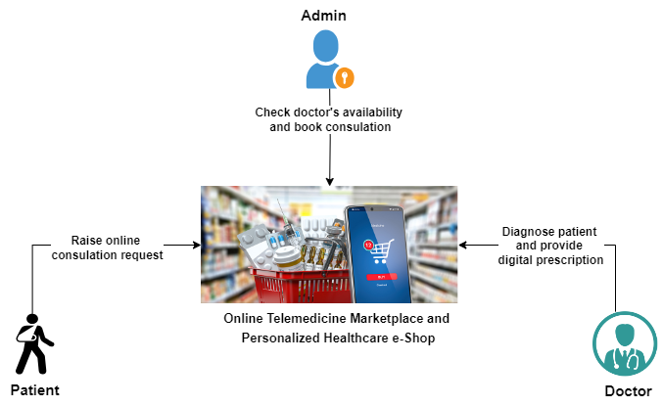

Figure : Low-level design of the proposed telemedicine e-shop system

### High-level design (solution architecture)

The high-level design focuses on explaining the software system architecture that can be used in developing a robust system. It depicts an inclusive overview of the whole system by recognizing the major components that would be developed for the proposed system and its interfaces (Lteif, 2024). This section will provide an inclusive architectural style guiding the overall design and deployment of the proposed software system.

#### Overall architectural style

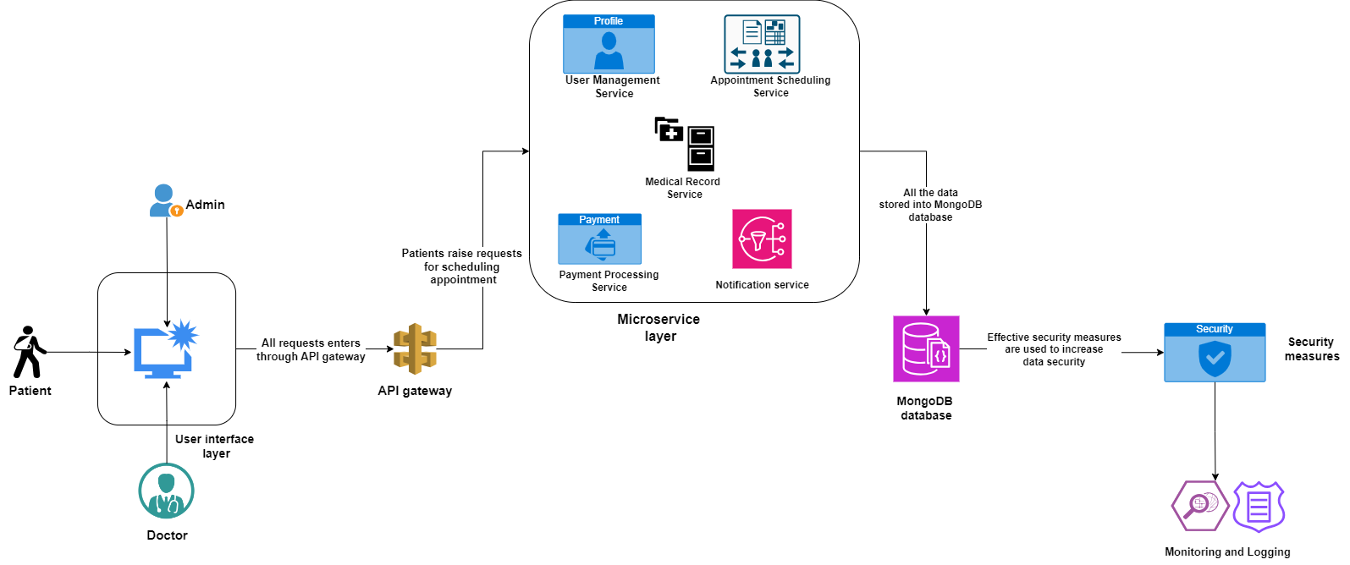

Figure : High-level design of the proposed telemedicine e-shop system

The above-illustrated diagram depicts a high-level design of the proposed system. This system comprises a user interface layer through which the patient, doctor, and admin can interact with the backend of this system. This interface is linked with the API gateway, which represents an entry point for all the client requests. The patient, admin, and doctor can sign and login to this system to access the system services. The API gateway is attached to the microservice layer, which manages the user’s registration, login, and profile. It handles the patient’s booking for online consultation along with all the patient’s healthcare records and doctor’s prescriptions (Mulkalwar, 2023). It also has a payment processing service for handling payments, billing, and refunds. Also, it manages notifications, alerts, and reminders. Each of these microservices has its own MongoDB database for the easy storage of important data and information. Further, effective security measures are deployed to protect all the stored data in the database. Moreover, cloud-based monitoring will be used for continuous monitoring of the system performance along with real-time troubleshooting and auditing.

# Solution Implementation and Deployment

This chapter provides a detailed discussion to bring the development process into real-life scenarios. Here the following methodologies, strategies, and steps will be provided to ensure that the proposed software platform has been successfully executed, tested, and positioned for effectively meeting all user needs and demands. The main goal of this section is to transform all the project requirements and designs into a highly functional, scalable, and secure solution that could be efficiently used by both healthcare professionals and patients.

## Hardware

This section depicts the details of the required virtual and physical resources to deploy the proposed telemedicine platform. The deployment scripts are used for automating the setup process of the network configurations, servers, storage, and installation of the required software packages. These deployment scripts help reduce errors, ensuring consistency, and speeding up the overall process of the proposed app deployment. This app deployment is managed using the Infrastructure as Code (IaC) with the support of Amazon Web Service (AWS) CloudFormation and Terraform tools for facilitating a seamless procedure of the cloud infrastructure provision and management (Adeniyi, 2022).

The topology represents a solid arrangement of all the important components of the proposed telemedicine app. The topology for this proposed app comprises cloud infrastructure, database, communication gateway, frontend, and backend. In this research load balancers and virtual private cloud topologies are used. The load balancers help in distributing the incoming traffic across several application instances to ensure higher availability. Further, the used cloud resources could be isolated within the virtual private cloud to enhance the control of network access and overall security measures. This topology demonstrated how different hardware components like databases and servers are organized to better support the operations of the proposed system. Further, an emphasis is made to ensure higher redundancy, availability, and scalability for handling diverse load capacities and ensuring continual services.

## Networks

### Network topology

The network topology of the proposed telemedicine software system is designed in a way of ensures highly efficient and secure communication among diverse components (Gillis & Nolle, 2021). It comprises a multi-layered architecture:

* **Frontend layer**: The frontend layer of this system’s network topology contains a user interface through which all the relevant users can interact with the system via a secured API gateway. The communication between this API gateway and clients is encrypted with the help of HTTPS.
* **Backend layer**: The backend layer of this system comprises several microservices for better handling the processing of data, business logic, and database interactions. These all microservices are organized using private subnets within the virtual private cloud to prevent direct internet access.
* **Database layer**: The database is hosted within the isolated subnets using strict access controls to enable only backend services for better communication with all microservices managed by the system.

### Cloud-hosted server topology

The used servers to host the proposed application are deployed on the cloud platforms, such as Google Cloud or AWS. This server topology comprises the following components.

* **RDS instances**: The Amazon RDS instances represent a cloud-based database atmosphere where the admins can spin multiple schemas and databases (Panwar, 2024). This research used RDS instances for the transformation of architectural style by offering highly scalable, resilient, and well-managed database services to perfectly meet all needs of microservices. Further, it can also enable the developers to better operate and scale the relational databases into the cloud platforms for automating the administrative tasks to enable the developers to focus on other important tasks.
* **EC2 instances**: The EC2 instances represent a virtual server in AWS terminology for requesting and provisioning the computer served within the AWS cloud. It can provide several kinds of instances of diverse sizes, comprising diverse configurations, networking resources, and storage capacity for better fulfilling the user’s needs and expectations (Awati, 2024). They can realize a balance among the memory, networking, and computing resources that make it ideal for the applications related to microservices, and code repositories. And database management.
* **Content delivery network**: CDN represents a geographically dispersed server for speeding up web content delivery. Any web platform has several servers through which data travels to reach out to the users. It may cause delays, so the CDN comprises several interconnected servers that are geographically closer to the users and transmit data faster to the users (Editorial Team, 2022). It mainly helped in this project to minimize the delay and latency during the network design communication. Our proposed system comprises a two-way communication; as client raises requests to the server and the server responds back. CDN realizes intermediate servers between the website and client servers for seamlessly managing the communication between client and server.

## Storage

Storage is one of the most essential and important parts of the proposed Telemedicine e-shop app that involves a highly effective and scalable schema of a database for capturing all the essential data entities along with their relationships. The below diagram depicts the detailed representation of all the entities related to the proposed system and the relationships among those entities.

### Entity relationship diagram

The storage for the proposed telemedicine e-shop is based on the relational database model. An entity relationship diagram represents a graphical depiction of the relationships among the concepts, events, people, places, and objects in a software system (Hanna & Biscobing, 2024). It uses data modeling methods for better defining diverse procedures and serving as the solid base of the relational database. It is very helpful to organize the generated data from a software system that could be represented by the relational structure. Further, it helped to realize a normalized database schema for the proposed system ultimately ensuring efficient storage and data integrity.

The below-illustrated diagram depicts an entity relationship diagram for the proposed Telemedicine e-shop system. This proposed system comprises 10 entities, namely users, patients, doctors, admin, appointments, prescriptions, medicine, orders, payments, and reviews.

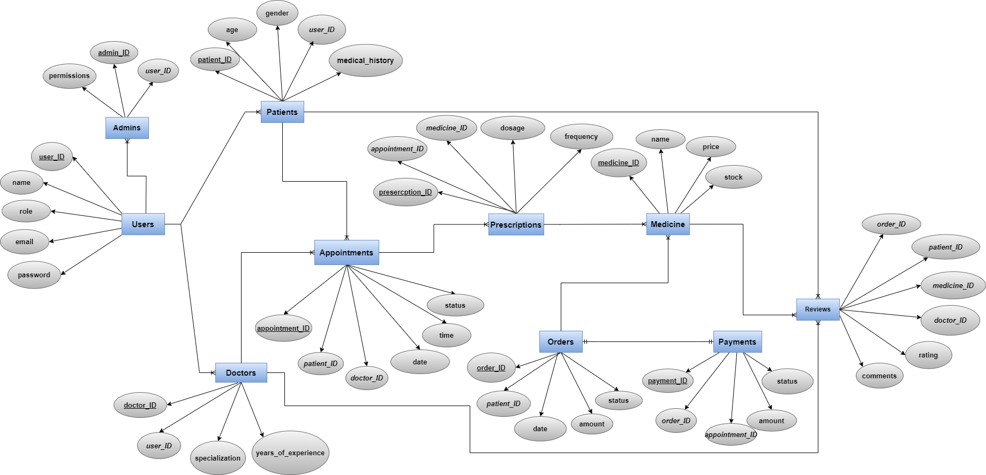

Figure : Entity relationship diagram

**Relationships**

* Users have one-to-many relationships with the patients, doctors, and admins.
* Patients have many-to-one relationships with users, one-to-many relationships with appointments, one-to-many relationships with orders, and one-to-many relationships with reviews.
* Doctors have many-to-one relationships with users, one-to-many relationships with appointments, and one-to-many relationships with reviews.
* Admins have many-to-one relationships with the users (S, 2024).
* Appointments have many-to-one relationships with patients, many-to-one relationships with doctors, one-to-many relationships with prescriptions, and one-to-many relationships with payments.
* Prescriptions have a many-to-one relationship with appointments and medicines.
* Medicines have a one-to-many relationship with prescriptions and a one-to-many relationship with reviews.
* Orders have a one-to-many relationship with patients and a one-to-many relationship with payments.
* Payments have a one-to-one relationship with orders and appointments.
* Reviews have many-to-one relationships with patients, doctors, and medicines.

## Software

### Programming language

For the development of the proposed Telemedicine e-shop app, Python programming language is used due to its higher scalability, versatility, and ease of use. The necessary code to design the system backend is developed using Python while better exploring the content of the website. Also, it offers several built-in libraries and frameworks to ease the overall development process. Python demonstrates a practical ability and agility throughout the app development process along with the Django web development framework to realize a fast and clean development of the proposed system.

This programming language largely helped during this project to offer seamless support to the required libraries related to the web service tools, internet protocols, and operating system interface (Singh, 2024). It facilitates excellent readability to easily read and understand the code while ensuring compatibility with the diverse operating systems. Also, it reduces the app development costs through the test-driven approach by enabling the developers to simultaneously write and test the codes.

### Front-end development

* **React with Vite**: In this research, I used **React JS** with **Vite** to develop the front end of the proposed application. React JS is one of the most powerful JavaScript libraries mainly used to build interactive interfaces, especially for single-page applications or websites. Vite is an advanced front-end development tool that offers a faster development atmosphere for React and other relevant frameworks. Together they helped me in realizing a user-friendly and highly responsive front-end for the proposed application.

### Back-end Development

**Web development framework**: I used the **Django** development framework, which is a popular and most frequently used Python web framework to realize a clean design and robust development for the proposed web platforms (Ashley, 2020). It has robust built-in features, scalability, documentation, security, and strong community support.

### API Integration

API integration plays a crucial role in enabling the developed software system to seamlessly interact with the databases and other third-party services. For the development of the proposed online telemedicine personalized healthcare e-shop, I have used several API integrations, such as user authentication API, EHR system integration API, payment gateway API, video consultation API, shipping/logistic API, and personalized recommendation API. It helped a lot to ensure a seamless integration of the proposed web platform’s front-end and available services at the backend.

#### JWT token

This proposed system generates JWT toke through its backend servers, comprising user-centric details, such as IDs and roles for authentication and validation. The signup and login authentication APIs are redirected to ensure seamless and secured user authentication using JWT tokens. It realized a robust security framework for the proposed app while maintaining an efficient user service experience across all the provided services.

### Database

In this research, I used a **MongoDB** database, which is a NoSQL database that can enable the proposed system to flexibly store the obtained data from various services in JSON format, known as BSON. It is suitable for this application development task because this project needs faster, secure, and extremely scalable data storage (Williams, 2023). As this proposed application will deal with complex healthcare data, this database will facilitate a seamless processing and analysis of this data within the database.

## Class diagram

A class diagram represents a kind of unified modeling language (UML) diagram that is used in software development for visually representing the structure and relationships among the different classes related to a specifi c software application. UML represents a standard modeling language for designing effective software design and documentation. They provide a high-level overview of the design of a software system for better communicating and documenting software systems. The classes are represented using boxes and the lines connecting them represent relationships among the classes.

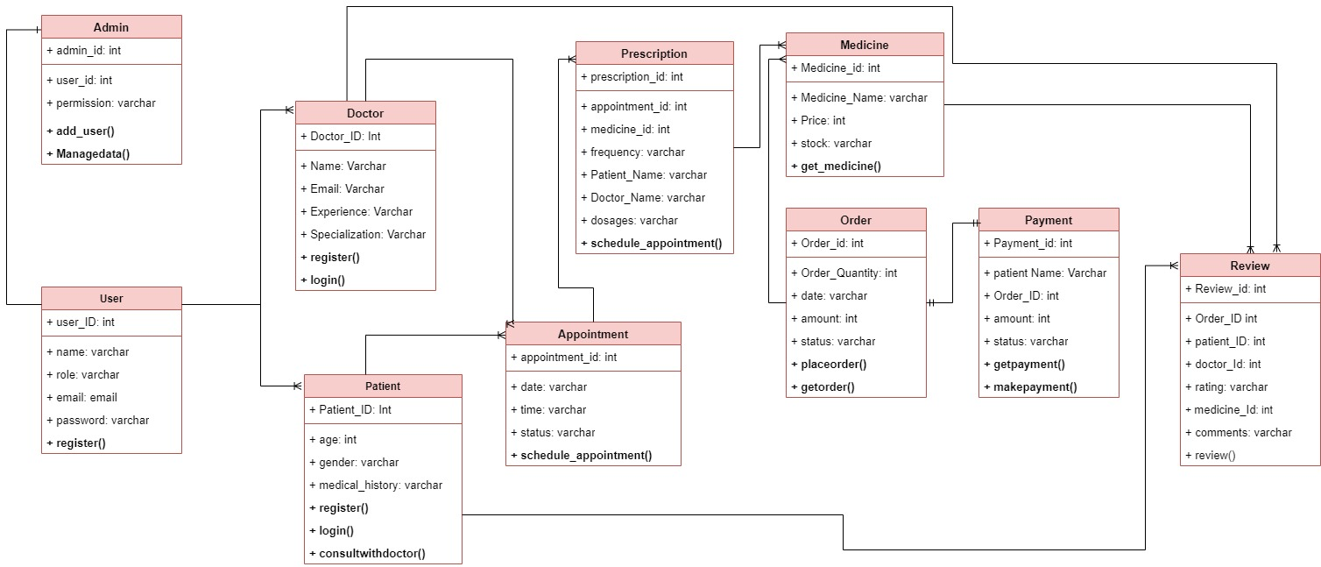

Figure : Class diagram

The above-illustrated diagram depicts the created class diagram for the proposed web platform. It comprised 10 classes, namely admin, user, doctor, patient, appointment, prescription, medicines, order, payment, and review. All these classes have their respective attributes and share a specific relationship with the other classes.

## System development

### Backend development

The below-illustrated figure depicts the details of the used APIs for the purpose of user authentication based on the provided credentials, such as email/user name and password. The user can only log in to the system after the successful authentication.

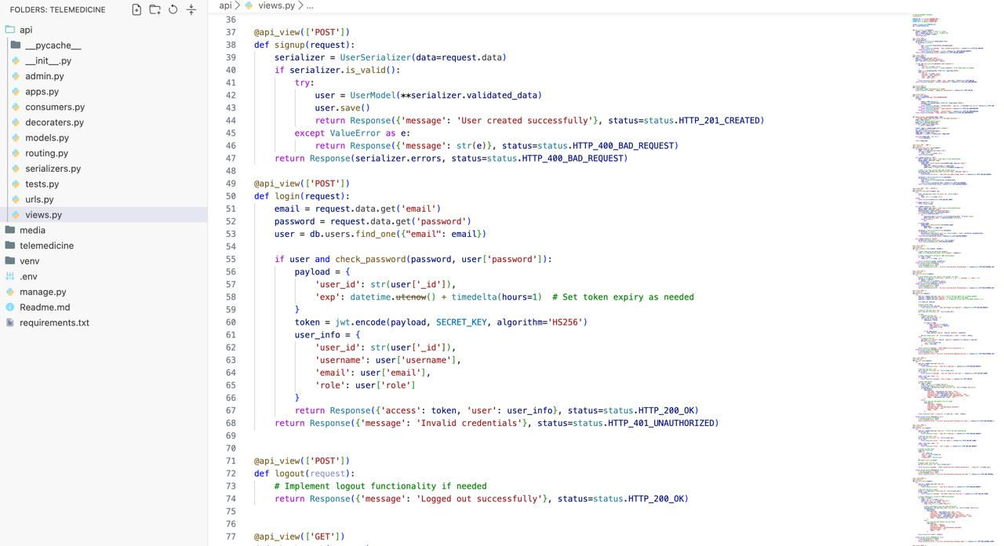

Figure : Authentication APIs

The below-illustrated figure depicts the details of all the used URLs, such as signup, login, logout, authorization, medical items, item’s category, list of all doctors, add to cart, cart items, checkout process, user orders, appointment request, appointment status, medicine search, chat room, patient appointment details, and patient bill.

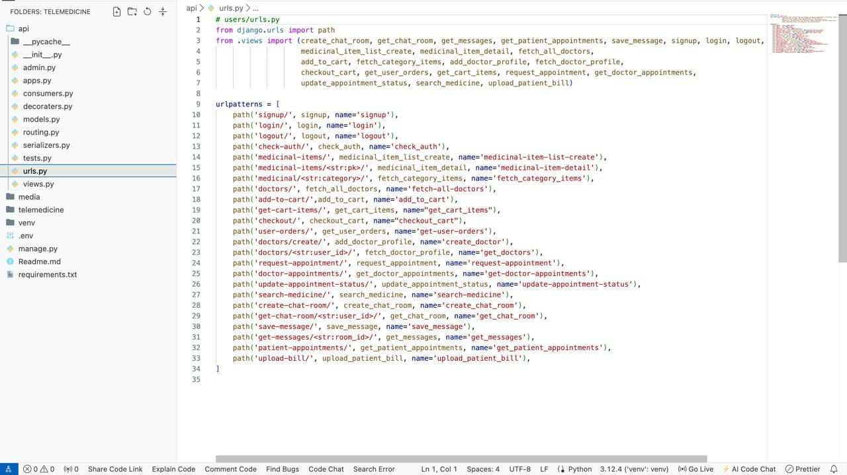

Figure : URLs

The below-illustrated figure depicts the details of modules or tables. The system used the MongoDB database to securely store the details related to patients, healthcare professionals, medicines, and other healthcare products or services.

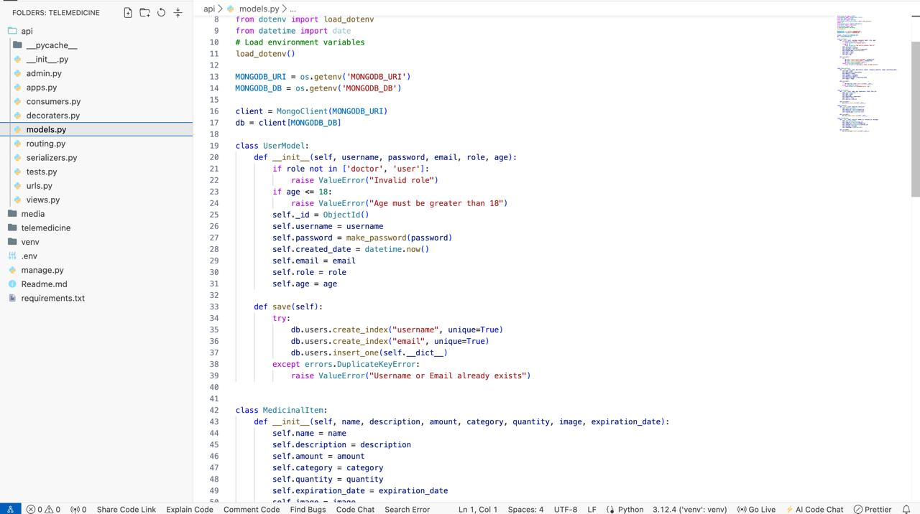

Figure : Models (Tables)

The below-illustrated figure depicts the details of the code to authenticate the user credential before logging into the system. This project used JSON Web Token (JWT) for authentication purposes to identify and authenticate users and let the servers establish trust between the unknown client and servers.

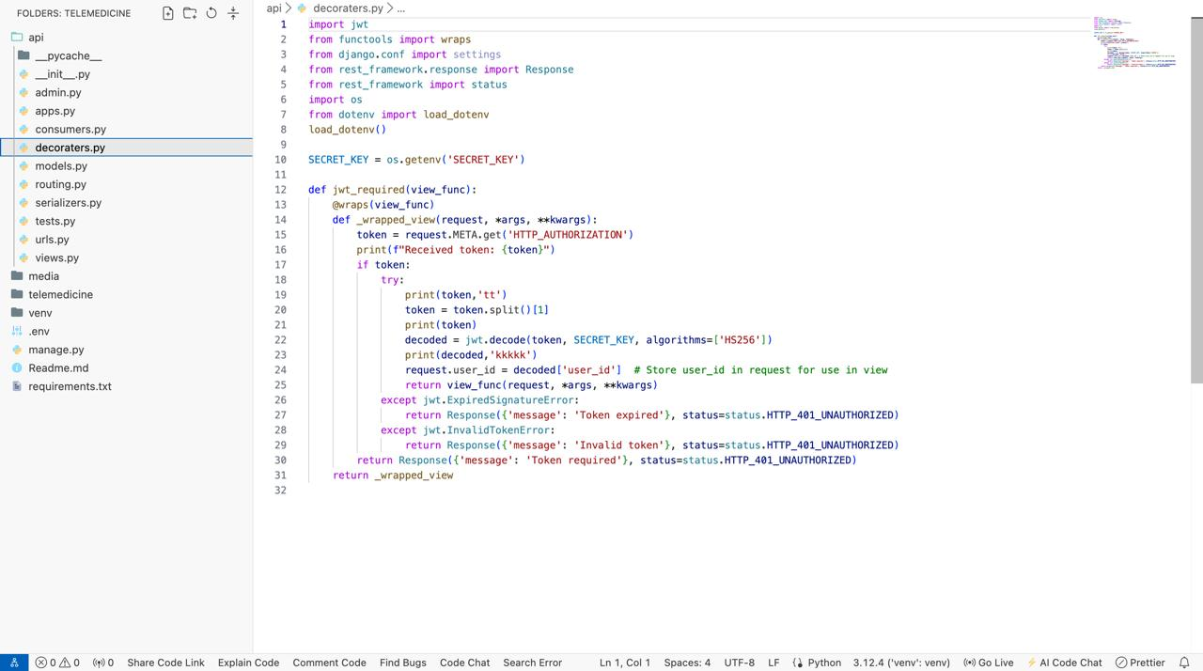

Figure : Authentication Check Code

The below-illustrated diagram depicts the details of all the necessary settings for this project.

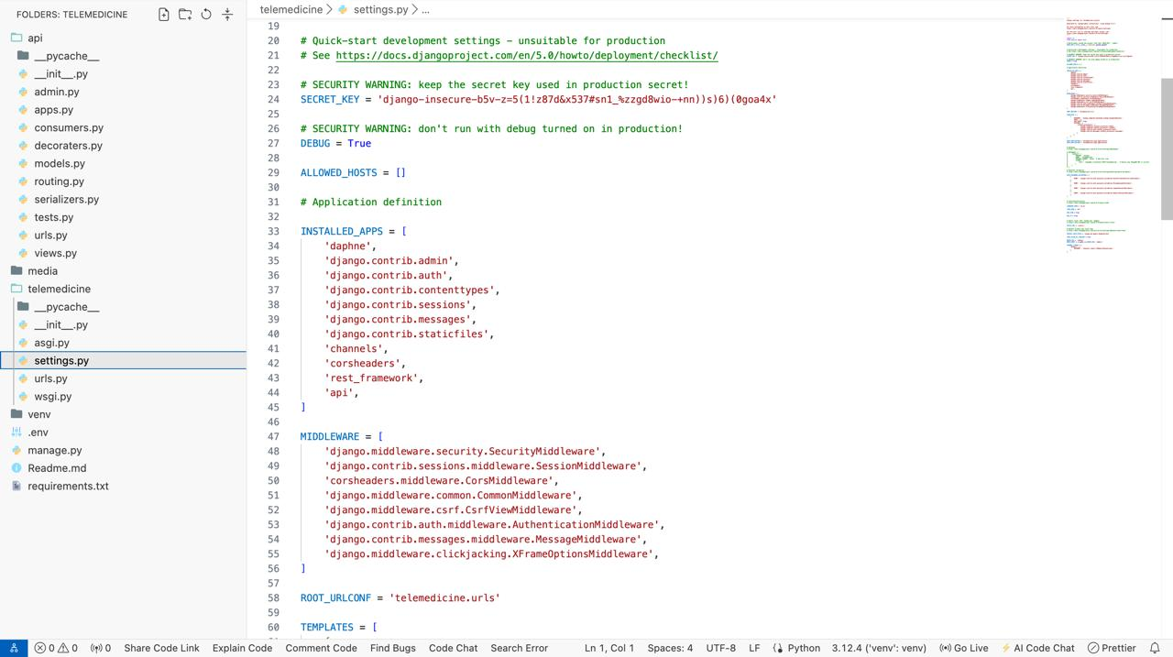

Figure : Project Settings

The below-illustrated figure depicts all the pages related to the front end of the developed web platform in this project.



Figure : Frontend Project Structure

The below-illustrated figure depicts the details of all the routing files, comprising path details toward the provided services by the proposed application. The major paths addressed are login, signup, cart, orders, products, categories, doctor selection, doctor appointments, appointment update, admin dashboard, medicines, and medicine categories.

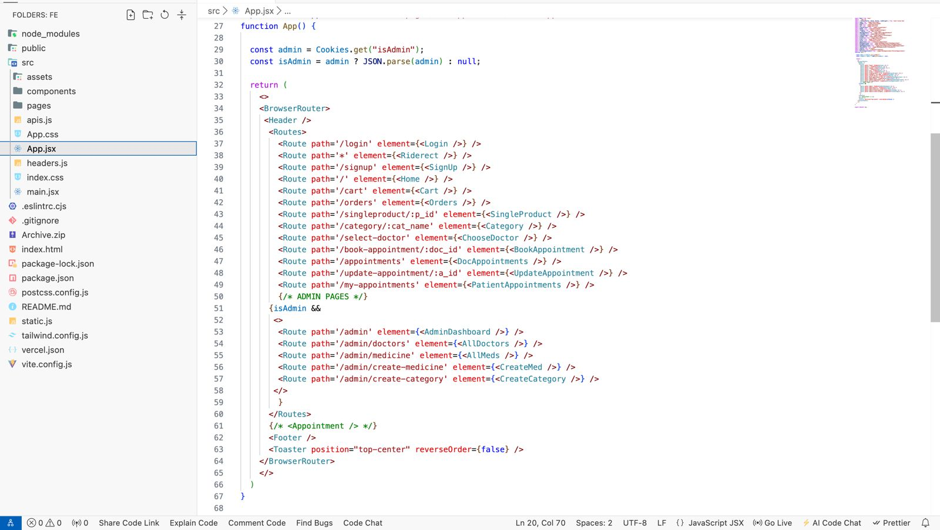

Figure : Routing File

The below-illustrated figure depicts the developed code to create a home page for the proposed web application.

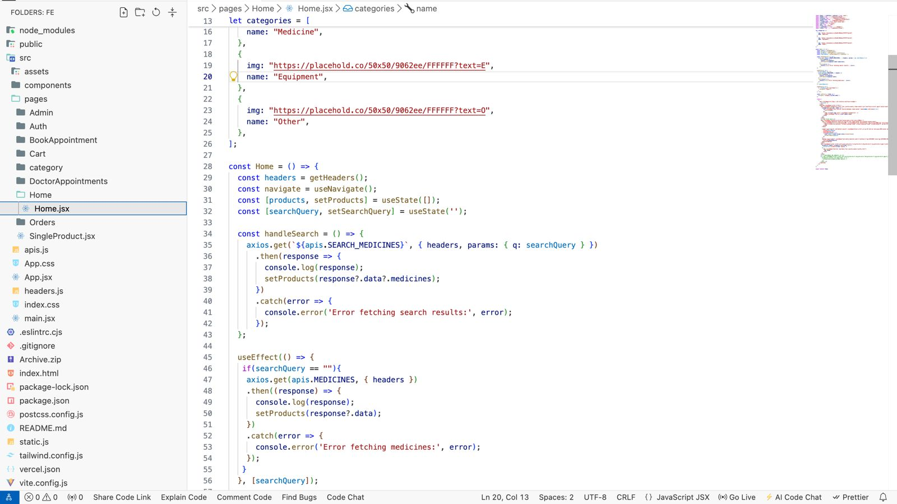

Figure : Home Page

The below-illustrated figure depicts the developed code to create a login page for the proposed web application. Here the user can log in to the system by providing an email and password.

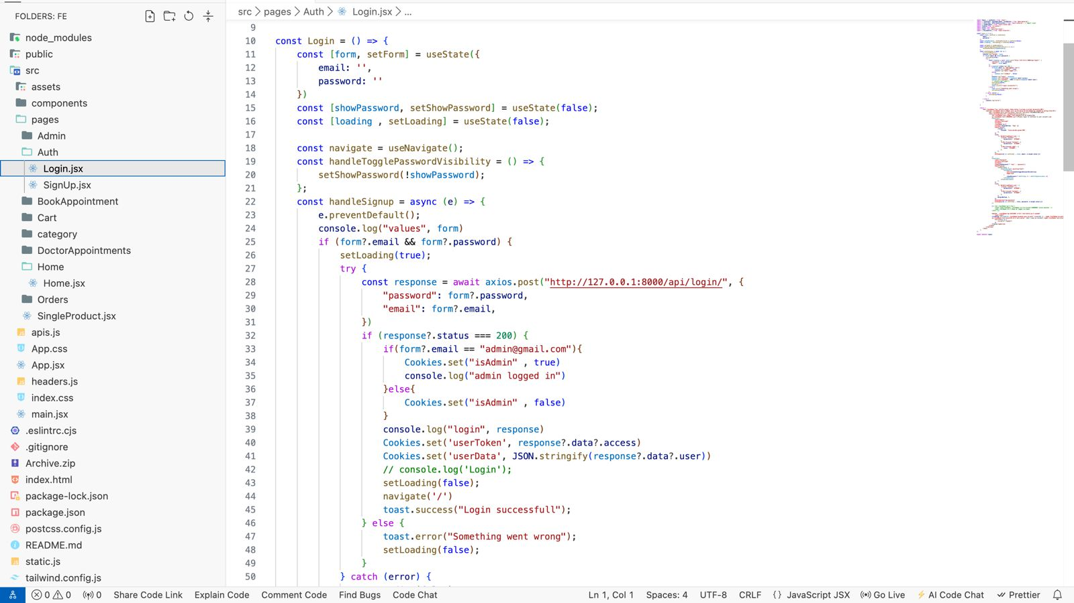

Figure : Login Page

The below-illustrated figure depicts the developed code to create a product category page for the proposed web application

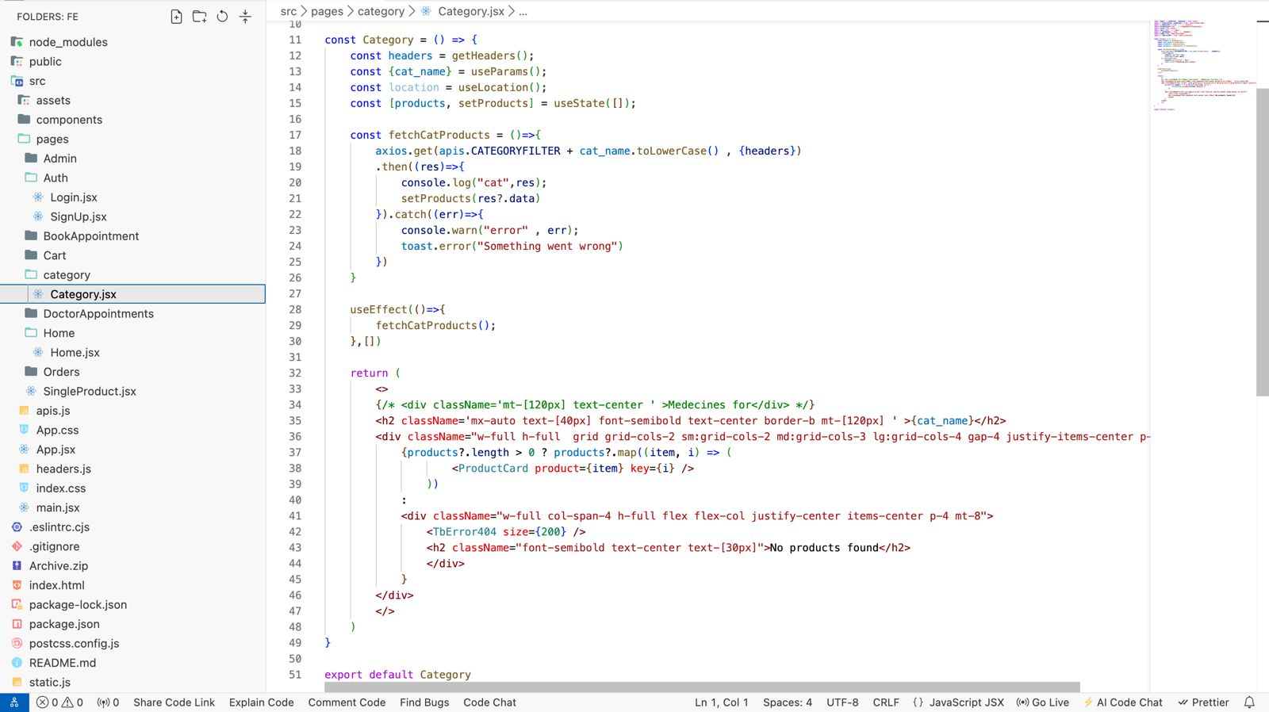

Figure : Category Page

The below-illustrated figure depicts the components folder, comprising all the components related to the proposed application.

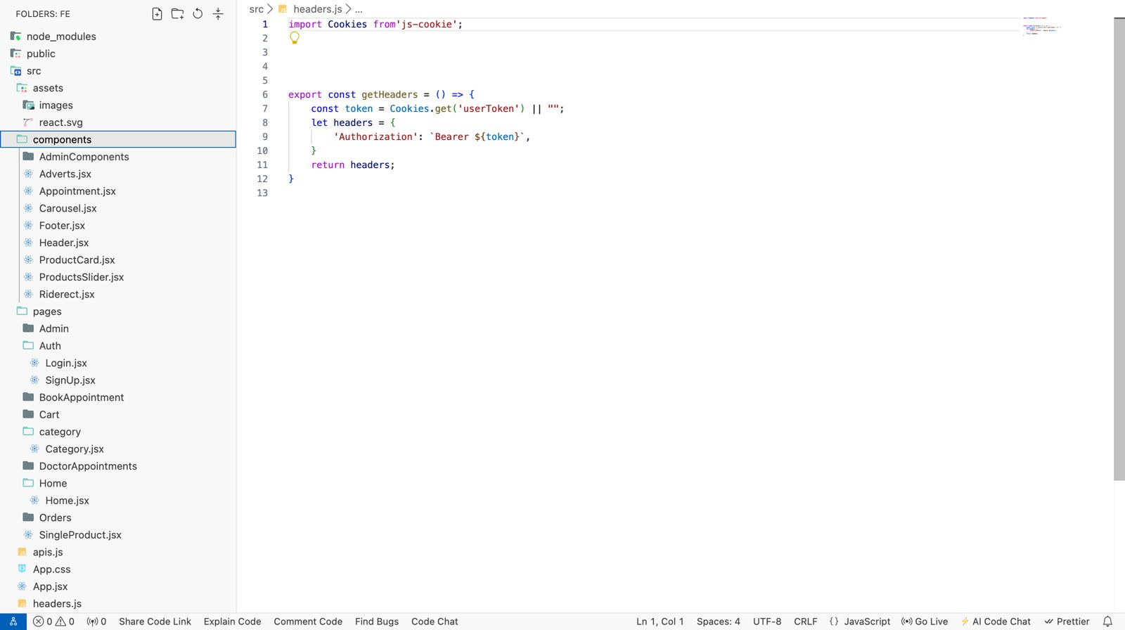

Figure : Components

### Frontend development

The below illustrated figure depicts the signup user interface. Here the user can register to the system by providing the details, such as username, email, password, age, and role.

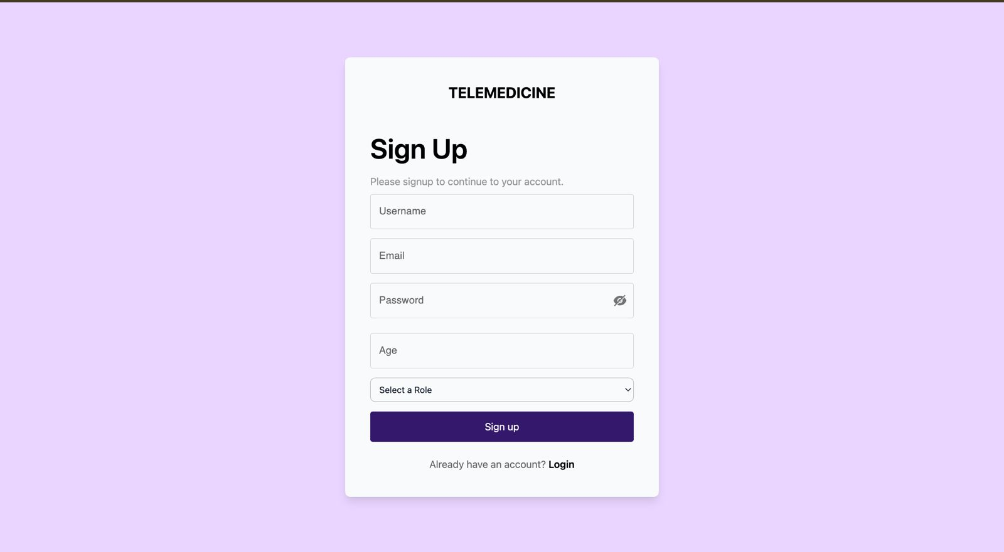

Figure : Signup page

The below-illustrated figure depicts the login user interface. Here the user can log in to the system by entering their email and password and clicking on the login button.

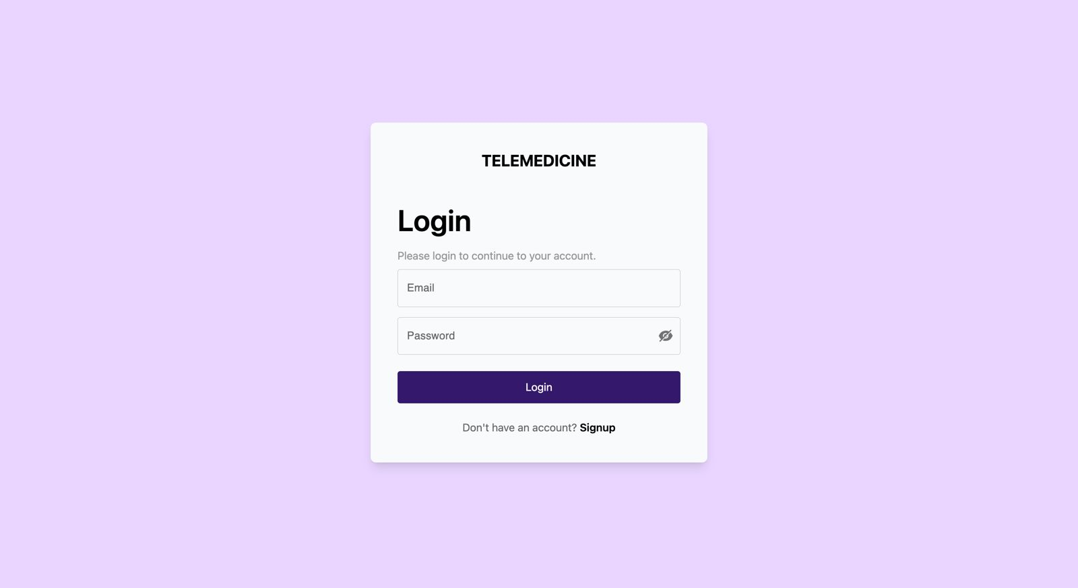

Figure : Login page

The below-illustrated figure depicts the home page of the system. Here the user can see the available medicine, equipment, and other healthcare products or services. Here the user can also search for any desired product using the given search bar. Here the user can also redirect to the cart.

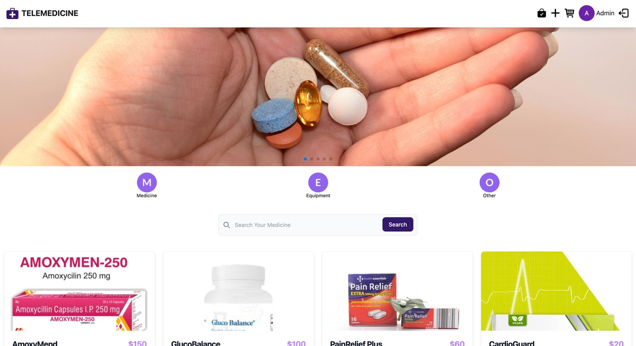

Figure : Home Page

The below figure depicts the details of various healthcare tools, medicines, and products with their name, prices, images, and brief descriptions. Here a quick links to home, cart, orders, and medicines are also provided along with the addresses and various social media platform links.

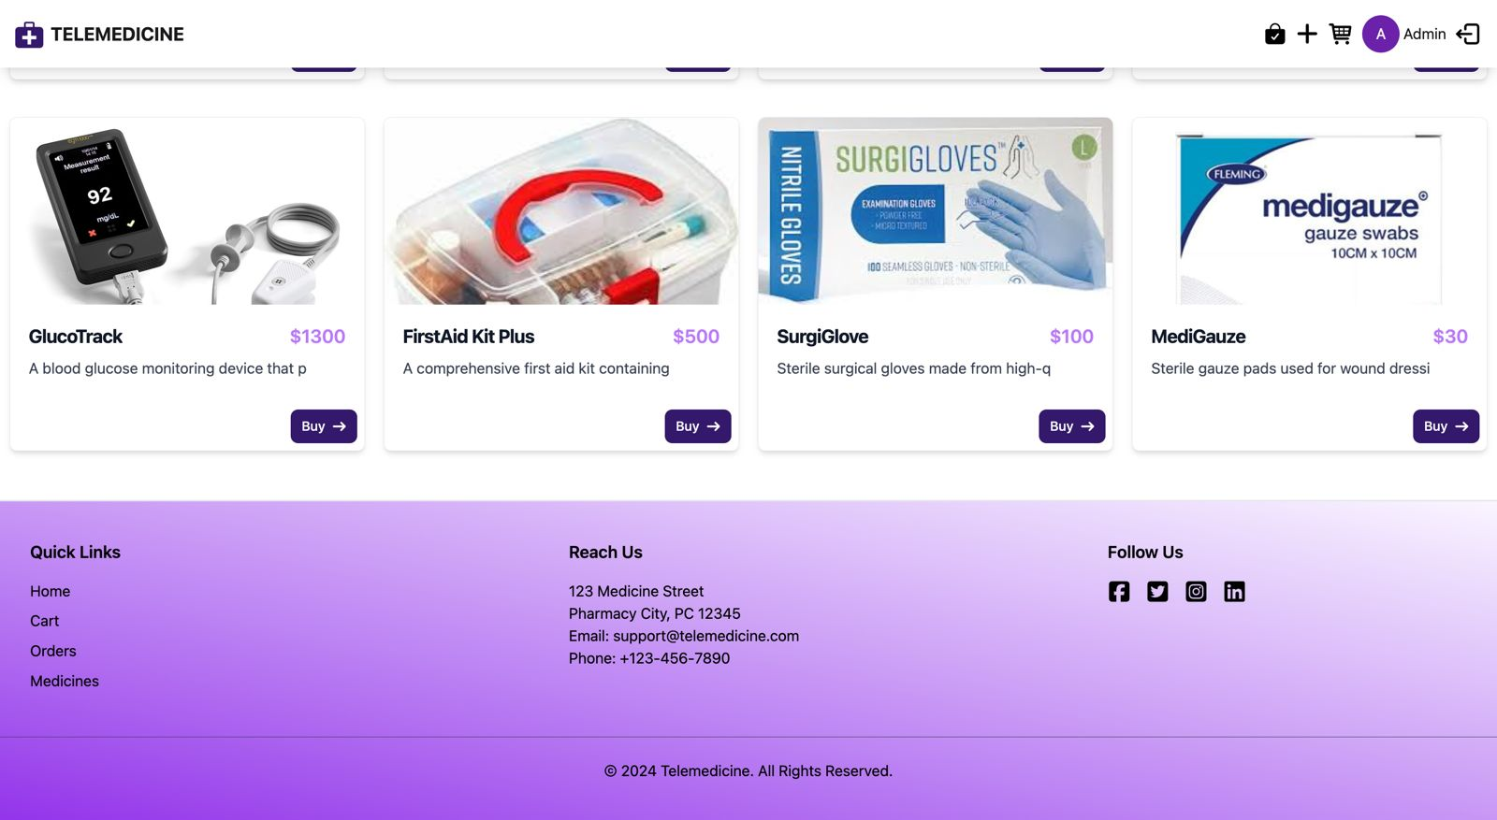

Figure : Available products

The below-illustrated figure comprises the categories of various medicines available on the proposed web platform. The main categroies are GlucoBalance, AnoxyMend, CardioGuard, PainReliefPlus, and AllerFree.

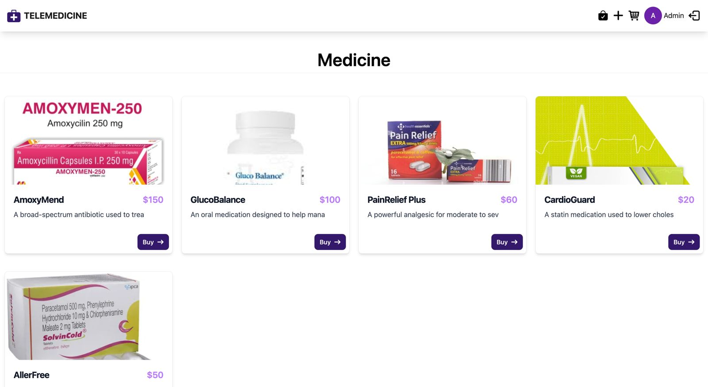

Figure : Category Page

The below figure depicts the search results after making a search by the users using specific keywords.

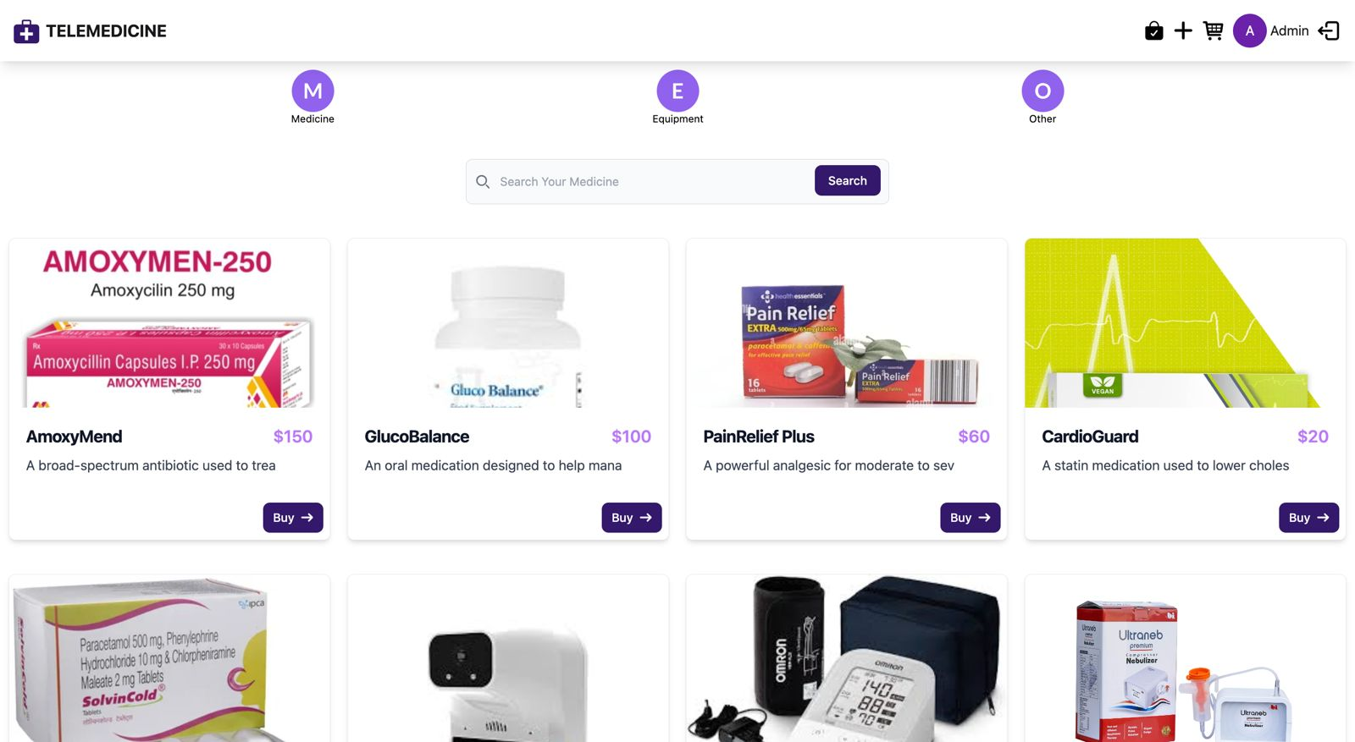

Figure : Search Page

The below figure depicts the product details page. It provides the details of the Surgical Glove, whose price is $100. It addresses that the Sterile surgical gloves are made from high-quality latex.

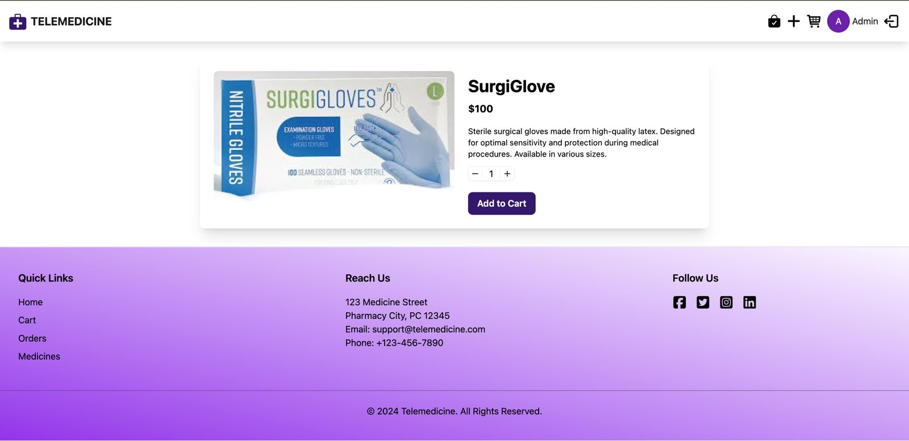

Figure : Details Page

The below-illustrated figure represents the cart page. This cart contains various telemedicines, such as GlucoBalance, GlucoTrac, NebulaNeb, and SurgiGlove. The total cart value is $3500 and a button to redirect the checkout page is also shown.

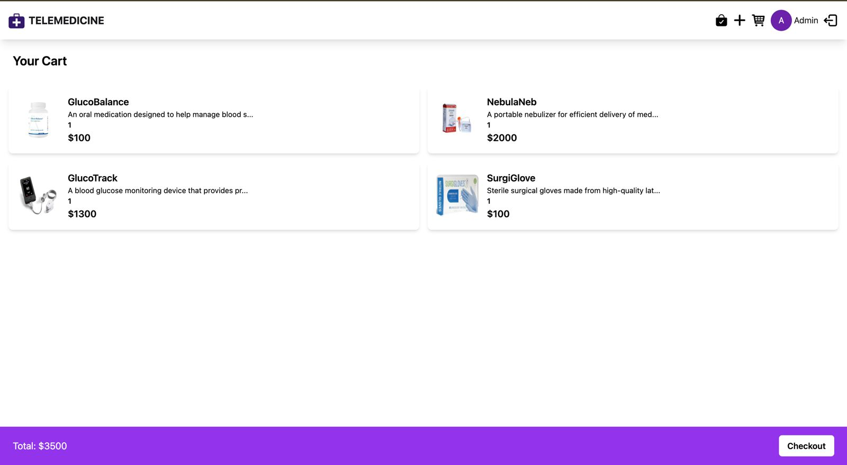

Figure : Cart Page

The below figure depicts the details of making an order, which contains PainRelied Plus and FirstAid Kit Plus. This order was placed on 29/07/2024 at 5:56 AM.

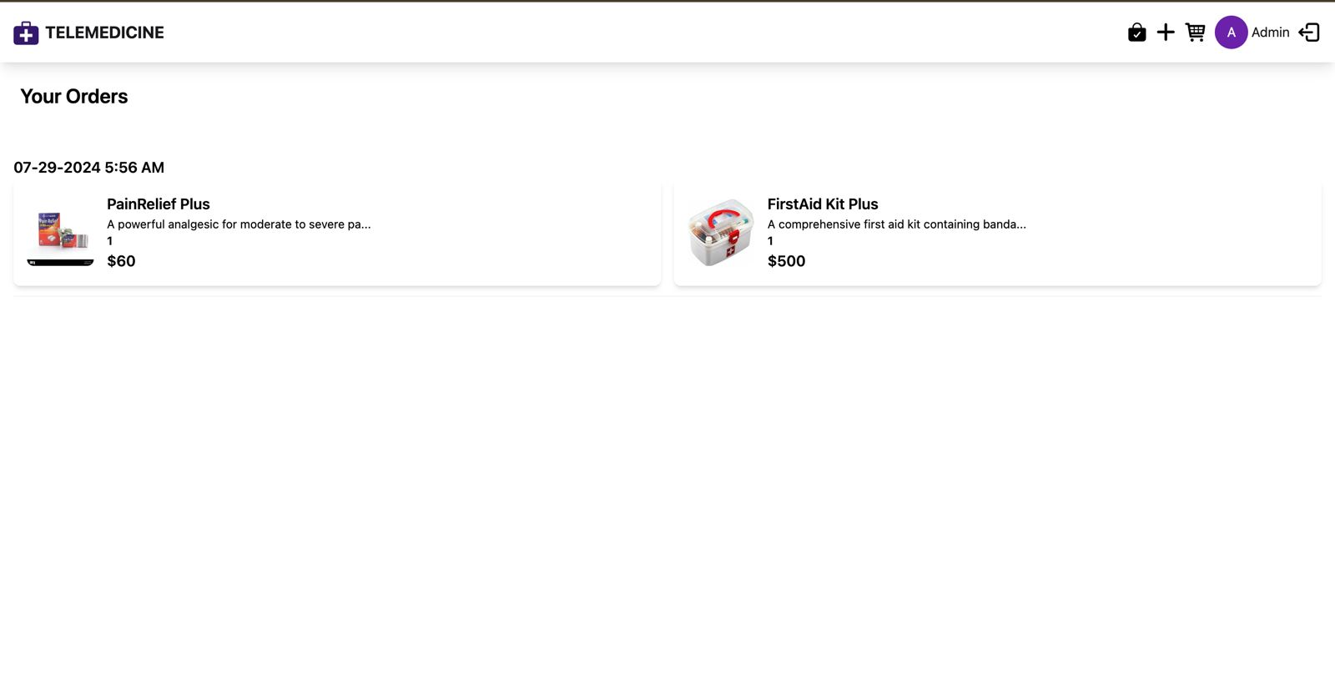

Figure : Orders Page

The below-illustrated figure depicts the details of the appointment booking page. Here the user has shown a list of the available doctors with their email IDs.

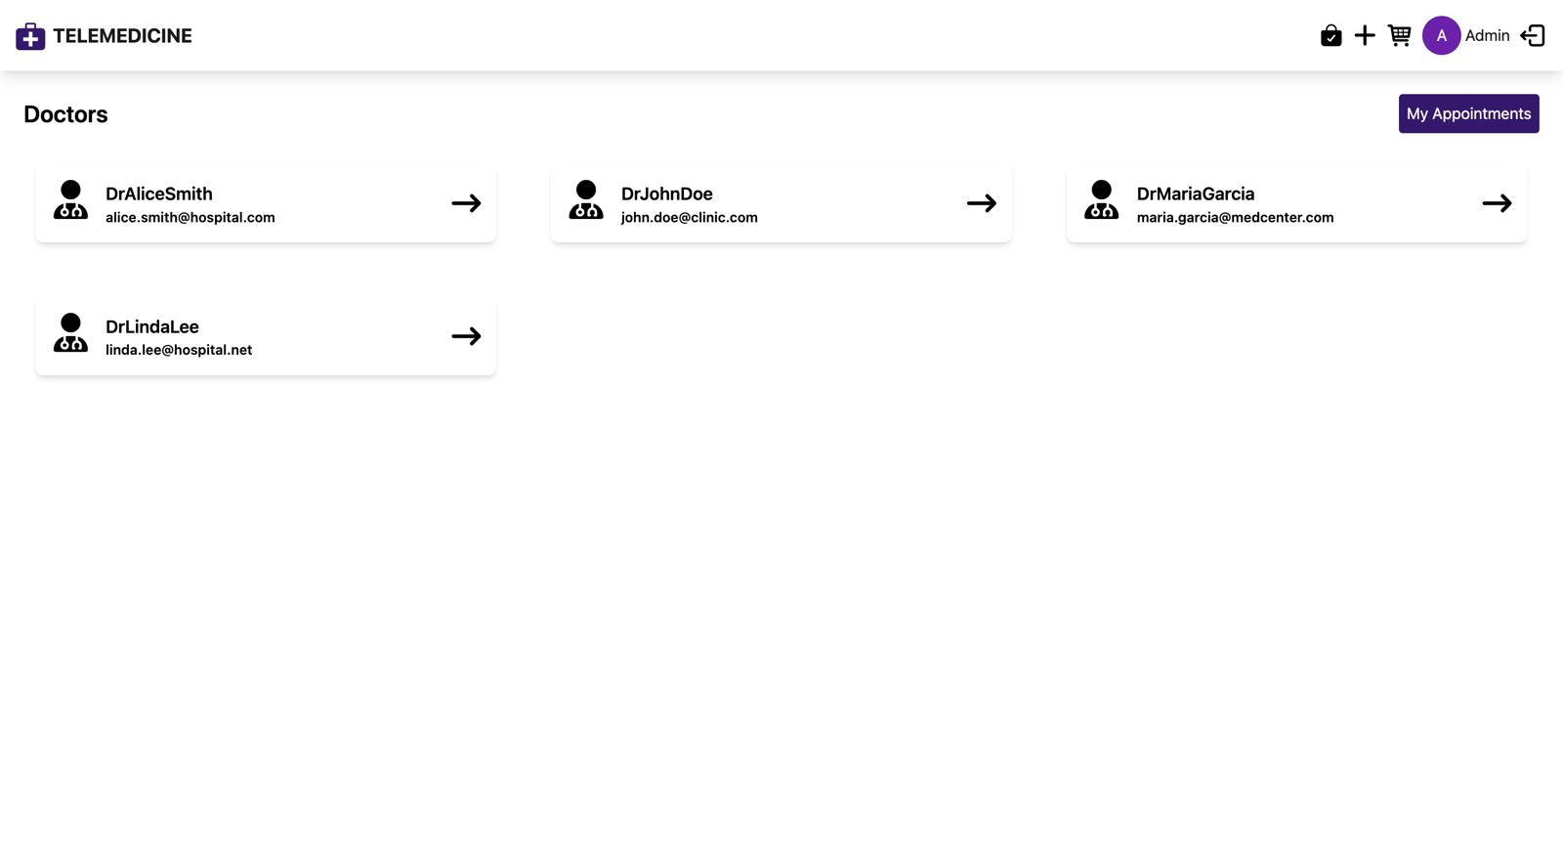

Figure : Book Appointment Page

The below-illustrated figure depicts the details of the booked appointment with Dr John Doe 22/08/2024 at 11:40 AM. The status is showing pending. Here the user has an option to chat with the doctor.

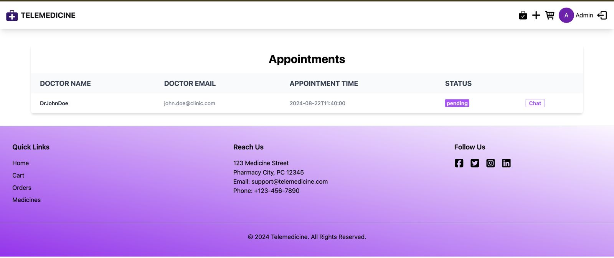

Figure : Booked Appointment Page

# Solution Evaluation

This chapter is based on the evaluation of the proposed project based on the development of personalized healthcare and telemedicine e-shop. In this evaluation section, a detailed assessment will be conducted for the effectiveness, functionality, performance, and user service experience with the help of different testing methods. This chapter mainly emphasizes identifying significant issues through a systematic testing procedure to ensure and validate that the intended requirements are fulfilled and met while ensuring the reliability and robustness of the proposed system for the end users. It will present and discuss the test plan, test cases, and test results.

## Test plan

Test plan refers to the process, consisting of all the test-relevant activities. It is developed at the diverse project levels by defining the products that need to be tested, testing procedures, and type of testing. This test plan is prepared by the test manager by employing various testing strategies for validating the system's functionality and robustness. Each of the testing phases is designed in a manner to address the key aspects of the proposed system while ensuring that all the set requirements throughout the testing phases are met well.

This test plan serves as the detailed blueprint of the changes as per the project progressions while staying up-to-date (Pittet, 2024). It forms a solid base for the project to conduct various testing activities and coordinate those activities among the Quality Analyst’s team. To identify the errors or bugs in the developed telemedicine app and validate its effectiveness while ensuring whether this app is performed as intended or not, the following testing methods are used.

* **Unit testing**: Unit testing represents a type of software testing, that mainly focuses on testing the individual components or units of the developed software application by isolating it from the whole system to ensure that it works as intended. The unit can be a function, method, module, or class. The unit tests are written by the developers to check and validate the code's correctness and ensure that it meets the specifications and requirements.
* **Integration testing**: Integration testing represents another type of testing in which diverse components or modules of the software applications are collectively tested to ensure that they are correctly integrated and work together as intended (Doshi, 2023) . It mainly aims to recognize the issues that may arise by combining the working of different components of the app.
* **Performance testing**: This type of testing method focuses on assessing the performance and responsiveness of the developed software under diverse workloads for recognizing potential bottlenecks related to the software system and optimizing the performance measures of the software application.
* **Regression testing**: Regression testing represents a type of testing that helps ensure that any modifications or changes in an existing software application do not pose any new errors or defects and adversely impact its current functionalities.
* **Acceptance testing**: This testing method confirms that the developed software application must fulfill the specified criteria of acceptance and be ready for an effectual deployment. Generally, the stakeholders or end-users perform this testing to ensure that the developed software meets their requirements and is well-fit for its envisioned purposes.
* **User experience testing**: This testing represents the last stage of testing for any software application. It focuses on testing the usability of the software application by evaluating the usability and user-friendliness of the developed software application (Elazar, 2024). It helps in assessing the ease and suppleness of the use of applications from the perspectives of users.

## Test cases

The test cases represent a specific format for performing software testing to ensure that the developed software application works as intended or not. It comprises a certain set of conditions that must be checked for testing any software application. In other words, it confirms that the resulting output meets or not the intended output, after the conditions are checked (McMullin, 2024).

Table : Test cases

|  |  |  |  |  |
| --- | --- | --- | --- | --- |
| **ID** | **Name** | **Objective** | **Input** | **Expected outcome** |
| TC01 | User Registration | Its main objective is to ensure that the new user successfully registers on the application. | User’s personal details (i.e., name, email, contact number, password) | The user successfully registered and received a confirmation email. , |
| UC02 | Scheduling appointment | It mainly aims to ensure that patients can easily schedule online appointments with the doctor. | Doctor ID, Patient ID, date, and time. | Appointment is created and both doctor & patient are notified about the appointment. |
| UC03 | Processing payment | It intends to ensure a seamless payment gateway for the patient. | Payment details (i.e., payment method, amount, transaction ID) | Payment successfully processed and invoice generated. |
| UC04 | User interface navigation | It aims to assess the ease of the system’s user interface navigation (McMullin, 2024). | Navigation paths and user clicks | Users could easily identify desired information, easily complete tasks, and navigate the website functions. |
| UC05 | System load | It seeks to evaluate the performance of the system during high user traffic. | Higher user traffic | The web system remained highly responsive and demonstrated an acceptable level of performance. |

## Test results

The test results represent the outcomes of the entire lifecycle of software testing. Adequate reporting of the test results represents an important part of the overall testing process. The tester needs to make a comprehensive report, comprising all the test results with the pass or fail status of the whole test cycle (Singh, 2023). The produced test results provide vital insights about the project deliverables that are crucial to sharing the project status with the stakeholders.

For this software project, six main testing methods were deployed to test the effectiveness of the proposed system. The obtained results from these testing methods are illustrated below.

* **Unit testing results**

This testing method focuses on testing the individual system components to ensure whether each method or function related to the proposed system is working as intended or not. It demonstrated that the users were able to successfully register and log in to the system using their valid input credentials and they received a confirmation email. It also validated that the system followed the email and password formats along with meeting all the security requirements.

* **Integration testing results**

This testing method validated that all the relevant components and modules work effectively and as intended while using them collectively (Ponomarenko, 2022). The users easily log in to the system using the provided credentials during the registration process. On any appointment booking, the proposed system correctly notified both patients and doctors via email. After the successful payment from the patient’s end, an invoice is generated and stored in the user’s profile.

* **Performance testing results**

This testing method demonstrated the stability and responsiveness of the proposed system under diverse conditions. It has been observed that the proposed system responded within 1.2 seconds under high user traffic. The database efficiently managed about 5000 simultaneous transactions with a 0.5 sec response time.

* **Regression testing results**

This testing method demonstrated that any recently made code changes did not pose any negative impact on the existing functionalities of the system (Summers, 2020). This project successfully integrated the online consultation features with the appointment scheduling features and it did not cause any errors or bugs.

* **Acceptance testing results**

This testing method demonstrated that the proposed system met the needs and expectations of all the involved stakeholders. This testing addressed that the proposed user successfully registered and logged in to the system, booked an appointment with the doctors, had an online consultation with the doctor, received an online prescription, and successfully made payment. All of the users were satisfied with the usability and performance of the proposed system.

* **User experience testing results**

This testing method demonstrated the effective usability and satisfaction of the end users. They reported that the user interface of the proposed system is highly intuitive and user-friendly. They easily navigated and completed most of the tasks. Moreover, this system demonstrated an exceptional level of accessibility, simplicity, and efficacy.

The overall testing results indicated that the proposed system is ready to deploy in real-world scenarios. However, some minor improvements could be made to further optimize its accessibility and performance measures.

# Critical Evaluation

This chapter represents a critical evaluation of the project based on the development of the Telemedicine Commercial Center and Personalized Medical Services e-Shop. It will provide a critical evaluation of this proposed system against the specified objectives to address and validate whether this proposed system meets or not those objectives. Here we first evaluate the proposed system against all the objectives. Then provide a critical review of the initially developed project plan and any deviations that arise during the project with the possible reasons behind those deviations. Finally, a reflection will be provided on the learned lessons throughout this project.

## Evaluation against objectives

### Python and ReactJS to develop a highly responsive platform

In this project, I used Python with Django framework for the backend and React for the front end of the proposed telemedicine marketplace web platform. The integration of Python, Django, and React provided several benefits for this project by catering to the unique needs of the development of the proposed app (Singh, 2023). They enabled the developers to better leverage the potential of each technology to create a highly effective and responsive web platform. Python provided excellence in data manipulation and server-side programming, Django enabled a seamless implementation of JavaScript on the server end, and React simplified the process of development of an interactive user interface. Python and Django also significantly optimized the scalability and performance of the proposed system.

### MongoDB database for secure healthcare data storage

The healthcare sector comprises huge complex data that need to be transformed into vital insights to enhance patient care by advancing clinical outcomes. I used the MongoDB database for this project which helps in bringing the medical records and healthcare data from this legacy database for developing a unified view for the patients. It offered a flexible data model for unifying the dissimilar data sources for offering an integrated platform for the patients by integrating wearable data, electronic healthcare records, and patient-centered data for offering personalized healthcare services (Gohn et al., 2022). It realized a robust development platform by securely storing the obtained data from various services run on the proposed web platform. It efficiently handled all the complicated queries while facilitating quick access to the information related to patients and various healthcare products.

### Increased access to healthcare products and services

The proposed telemedicine marketplace and personalized healthcare web platform efficiently integrated various telemedicine services into a single web platform to let the patients conveniently access these services at any time without physically making appointments with the healthcare professionals (DeGuzman et al., 2022). This platform offers an online consultation booking system, secure messaging, and video consultation services. Further, this e-shop is compatible with all types of devices, so that any user can easily use this along with a feature of multiple payment options. Further, it provided seamless shipping & logistic services to deliver medicine and other healthcare products to the user’s doorstep with the real-time order tracking feature.

### Healthcare professional’s role in telemedicine and personalized healthcare

Healthcare professionals have a central role in the proposed telemedicine e-shop. This proposed telemedicine web platform provided them access to overall patient health records, virtual consultations, and personalized treatments and meditations (Dongre et al., 2021). This process is easy through the electronic health records and secure communication platforms, The healthcare professional can obtain patient’s data from the EHR system to better assess the patient’s diseases and healthcare needs and then provide treatment accordingly. Further, this web platform offered all the essential resources and tools for enabling healthcare professionals to easily adapt to the online atmosphere of the proposed web platform to efficiently deliver healthcare services.

### Role of telemedicine and personalized healthcare in increasing patient satisfaction

The efficacy of the provided healthcare services by the proposed telemedicine app was assessed through patient reviews and feedback surveys. The proposed web applications significantly enhance patient care and healthcare services ultimately increasing the satisfaction level of the users (Mason et al., 2022). The integration of e-commerce with telemedicine realized a unified platform to let the users take virtual consultations with expert doctors and purchase prescribed medicines online through this unified system. Further, its abilities and features will be continuously updated to meet the evolving needs and demands of the users.

## Plan and explanations for any deviations

The primary project plan was focused on the development of the online telemedicine marketplace and personalized healthcare e-shop using ReactJS for the front end, Python & Django for the backend, and MongoDB for the database to securely store and retrieve relevant data (Singh, 2023). The project plan comprised multiple phases, such as requirement gathering, project design, project development, testing, deployment, and continuous monitoring. However, the evolving project requirements, unexpected challenges, and user feedback posed several deviations during this project. The project timeline was extended by 3 weeks due to comprehensive requirement gathering and analysis, third-party API integration, deployment of security measures, and rigorous testing. However, these deviations might caused certain delays in the project completion and delivery but overall they contributed to the development of a robust and feasible online telemedicine and personalized healthcare e-shop web platform. The extra time taken during the requirement gathering ultimately helped in collecting more comprehensive and in-depth information to better understand the precise requirements of this project. The integration of multiple APIs with third-party platforms while realizing a seamless user service experience needed more time to troubleshoot the issues and ensure that all the relevant system components work smoothly together. The sensitive nature of healthcare data addressed the need for more robust security measures during the implementation phase. It led to advanced monitoring systems and multi-factor authentication systems for better identifying and preventing unauthorized access (Dongre et al., 2021). It helped the proposed app in ensuring compliance with the applicable healthcare rules & regulations while efficiently protecting the sensitive data of patients and other confidential healthcare data. The extra time taken during the testing phase helped validate the system's performance and robustness under different conditions while ensuring its efficacy to accurately sense the health conditions of patients and provide personalized treatment accordingly.

## Lessons learned during the project

This project has developed a robust telemedicine marketplace and personalized healthcare shop that comprises several phases, technologies, stakeholders, API integrations, security considerations, and many other attributes. From this project and associated issues or challenges, I have learned a lot of things and key lessons that helped me in enhancing understanding and polish my knowledge and skills (STATHOPOULOU et al., 2024). I will utilize these lessons in future relevant projects to better accomplish those projects. The first lesson I learned from this project is the importance of requirement gathering for any project It is very important to identify the project requirements familiarize yourself with each aspect of the project and develop a robust project plan. A significant amount of time should be given to this project phase for identifying all relevant things, aspects, and stakeholders, considering their needs, interests, and expectations. I understood the importance of considering the user demands and behaviors throughout the project and capturing user feedback in the early phases of the project to timely make any necessary changes that ultimately enhance the performance and usability of the developing software systems. The obtained feedback from users addressed that patients need ease of using telemedicine apps with their data security and privacy, whereas healthcare professionals need the ability to easily access patients’ medical data and manage consultation services. For any project, it is very important to comply with regulatory standards like the General Data Protection Regulation (GDPR) and the Health Insurance Portability & Accountability Act (HIPAA) to ensure effective security and privacy measures (Said et al., 2024). I have dedicated a signification amount of resources and time to better understand and implement the most acquiescent data storage throughout the development of the proposed web platform. This proposed platform has to offer several integrated services, such as electronic health records, secure healthcare data storage, video consultation, payment gateways, and personalized healthcare recommendations. This seamless integration requires standard APIs and consistent data formats across diverse components of the system. A user-friendly and easy-to-navigate user interface is important for any software application or web platform considering the needs of both tech-savvy users and users who are less familiar with digital technologies. In this project, I have conducted multiple iterations during the system design considering user feedback. Any software system must be compatible and scalable to easily manage the increased number of users while ensuring faster load time and minimum downtime. I learned the significance of selecting effective cache mechanisms and cloud infrastructure for efficiently handling peak user traffic without any performance degradation. Personalization is very important in the healthcare sector to provide precise treatment and tailored healthcare services as per the patient’s health records and medical history. In this project, robust algorithms are developed for better analyzing the health data of patients and providing personalized treatment and healthcare services. Further, I learned the importance of rigorous testing to ensure and validate the functionality and effectiveness of the proposed system while ensuring that the sensitive data related to patients, healthcare professionals, and medication remained secure. A secure payment gateway is essential for this proposed system with features like easy refunds and subscriptions (Battineni et al., 2021). Moreover, I learned the importance of real-time consumer support, marketing campaigns, cybersecurity, partnerships, and continuous updates and improvements. These learned lessons address the significance of a user-centered strategy, agile development methods, and robust security features to develop a highly resilient and compatible healthcare solution platform.

# Conclusion and Future Work

## Conclusion

This project has successfully developed and implemented a robust online telemedicine marketplace and personalized healthcare e-shop web platform to enhance patient care and healthcare outcomes while enabling patients to conveniently appoint consultation sessions with healthcare professionals and get online prescriptions, medicines, and other healthcare services. It yielded the most valuable research insights and outcomes driver by the key research objectives, such as using Python & ReactJS to develop a robust web platform, using MongoDB database to securely store sensitive healthcare data, providing seamless access to healthcare products & services, addressing the importance of healthcare professionals in online telemedicine and personalized healthcare services, and role of the proposed application to enhance patient care and overall healthcare outcomes. A user-centric design approach was used throughout the development of the proposed web platform by involving the users and stakeholders and considering their needs, demands, and expectations. The testing methods largely helped to validate the effectiveness of the proposed system and ensured that the system functioned as intended. The system has a highly user-friendly interface with easy-to-navigate functionalities to enhance the overall user experience. Moreover, the proposed web platform demonstrated robust security measures to efficiently protect the sensitive data related to patients and other healthcare services. However, the proposed system addressed the challenges of managing the security and privacy of the evolving complex healthcare data and ensuring compliance with the applicable regulations.

## Future work

To address the currently faced challenges and further advance the proposed application, the following avenues can be adopted to conduct future research.

* Future research should focus on developing and integrating more effective, robust, and sophisticated machine learning, artificial intelligence, and predictive analytics technologies for further improving personalized healthcare services (Chander, 2021). A natural language processing method can also be leveraged to better interact with the patients and understand their behaviors and sentiments.
* The range of offered telemedicine and personalized healthcare products & services can be expanded to optimize the capabilities of the proposed software systems in delivering better patient care and healthcare outcomes.
* The Internet of Things and wearable healthcare services can be integrated with the proposed telemedicine web platform for offering real-time and highly precise monitoring of patients’ health to ultimately optimize personalized healthcare services.
* They should also leverage the potential of blockchain to secure data storage and sharing along with robust security measures to defend the growing cyber threats and vulnerabilities.
* Future research also needs to expand the market research with the linguistic, cultural, and regulatory considerations to expand the reach of this proposed platform beyond the geographic regions to better meet the patient’s needs for local payment methods and languages (Gruhn, 2024).

# References

Abdel-Wahab, M., Rosenblatt, E., Prajogi, B., Zubizarretta, E., & Mikhail, M. (2020). Opportunities in telemedicine, lessons learned after COVID-19 and the way into the future. *International Journal of Radiation Oncology* Biology* Physics*, *108*(2), 438-443. <https://www.ncbi.nlm.nih.gov/pmc/articles/PMC7462967/>

Adeniyi, K. (2022, October 31). *How to implement infrastructure as code with AWS*. freeCodeCamp.org. https://www.freecodecamp.org/news/how-to-implement-infrastructure-as-code-with-aws/

Aggarwal, C. (2024, July 9). *Difference between exploratory research and Descriptive Research - Shiksha Online*. Study in India. https://www.shiksha.com/online-courses/articles/difference-between-exploratory-research-and-descriptive-research/

Al Meslamani, A. Z., Aldulaymi, R., El Sharu, H., Alwarawrah, Z., Ibrahim, O. M., & Al Mazrouei, N. (2022). The patterns and determinants of telemedicine use during the COVID-19 crisis: A nationwide study. *Journal of the American Pharmacists Association*, *62*(6), 1778-1785. <https://www.japha.org/article/S1544-3191(22)00158-3/fulltext>

Alashek, W. A., & Ali, S. A. (2024). Satisfaction with telemedicine use during COVID-19 pandemic in the UK: a systematic review. *Libyan Journal of Medicine*, *19*(1), 2301829. <https://www.tandfonline.com/doi/pdf/10.1080/19932820.2024.2301829>

Alexander, S. (2024). MongoDB. <https://www.techtarget.com/searchdatamanagement/definition/MongoDB>

Antonacci, G., Benevento, E., Bonavitacola, S., Cannavacciuolo, L., Foglia, E., Fusi, G., ... & Stefanini, A. (2023). Healthcare professional and manager perceptions on drivers, benefits, and challenges of telemedicine: results from a cross-sectional survey in the Italian NHS. *BMC Health Services Research*, *23*(1), 1115. <https://link.springer.com/article/10.1186/s12913-023-10100-x>

Ashley, D. (2020). *Foundation Dynamic Web Pages with Python*. https://doi.org/10.1007/978-1-4842-6339-6

Awati, R. (2024, July 26). *What is an Amazon EC2 instance? types, features and pricing*. SearchAWS. https://www.techtarget.com/searchaws/definition/Amazon-EC2-instances

Barbosa, W., Zhou, K., Waddell, E., Myers, T., & Dorsey, E. R. (2021). Improving access to care: telemedicine across medical domains. *Annual review of public health*, *42*(1), 463-481. <https://www.annualreviews.org/doi/pdf/10.1146/annurev-publhealth-090519-093711>

Battineni, G., Sagaro, G. G., Chintalapudi, N., & Amenta, F. (2021). The benefits of telemedicine in personalized prevention of cardiovascular diseases (CVD): A systematic review. *Journal of Personalized Medicine*, *11*(7), 658. https://doi.org/10.3390/jpm11070658

Brittain, S., Ibbett, H., de Lange, E., Dorward, L., Hoyte, S., Marino, A., ... & Lewis, J. (2020). Ethical considerations when conservation research involves people. *Conservation Biology*, *34*(4), 925-933. <https://ora.ox.ac.uk/objects/uuid:3a925f04-1c41-447d-a194-e2995dbc9812/download_file?file_format=&safe_filename=Ethical%2Bconsiderations%2Bwhen%2Bconservation%2Bresearch%2Binvolves%2Bpeople.pdf&type_of_work=Journal+article>

Caulfield, J. (2023, June 22). *How to do thematic analysis: Step-by-step guide & examples*. Scribbr. https://www.scribbr.com/methodology/thematic-analysis/

Chander, B. (2021). Advanced deep learning techniques and applications in healthcare services. *Deep Learning for Personalized Healthcare Services*, 37–66. https://doi.org/10.1515/9783110708127-003

Cheong, H., Lyons, A., Houghton, R., & Majumdar, A. (2023). Secondary qualitative research methodology using online data within the context of Social Sciences. *International Journal of Qualitative Methods*, *22*, 160940692311801. https://doi.org/10.1177/16094069231180160

Cohen, J. P., Morrison, P., Dao, L., Roth, K., Duong, T. Q., & Ghassemi, M. (2020). Covid-19 image data collection: Prospective predictions are the future. *arXiv preprint arXiv:2006.11988*. <https://arxiv.org/pdf/2006.11988>

Colbert, G. B., Venegas-Vera, A. V., & Lerma, E. V. (2020). Utility of telemedicine in the COVID-19 era. *Reviews in cardiovascular medicine*, *21*(4), 583-587. <https://www.imrpress.com/journal/RCM/21/4/10.31083/j.rcm.2020.04.188/htm>

Conaty, F. (2021). Abduction as a methodological approach to Case Study Research in Management Accounting — an illustrative case. *Accounting, Finance &amp; Governance Review*, *27*. https://doi.org/10.52399/001c.22171

Contreras, C. M., Metzger, G. A., Beane, J. D., Dedhia, P. H., Ejaz, A., & Pawlik, T. M. (2020). Telemedicine: patient-provider clinical engagement during the COVID-19 pandemic and beyond. *Journal of Gastrointestinal Surgery*, *24*(7), 1692-1697. <https://link.springer.com/content/pdf/10.1007/s11605-020-04623-5.pdf>

Dao Ngoc Phuong, Q. (2021). Frontend for Python online learning platform. <https://www.theseus.fi/bitstream/handle/10024/512089/QuynhDao_Thesis%20Document.pdf?sequence=2>

Dawadi, S., Shrestha, S., & Giri, R. A. (2021). Mixed-methods research: A discussion on its types, challenges, and criticisms. *Journal of Practical Studies in Education*, *2*(2), 25-36. <https://oro.open.ac.uk/75449/1/Dawadi%2C%20Shreshta%20and%20Giri%202021.pdf>

DeGuzman, P. B., Garth, J., Sanjay, K., & Compton, R. M. (2022). *Extending Healthcare Access via Telemedicine in Public Libraries: A Mixed Methods Study*. https://doi.org/10.1101/2022.08.16.22278852

DIAS, Á. V. (2021). PLATFORM FOR AI-DRIVEN MEDICAL DATA ANALYSIS TO SUPPORT CLINICAL DECISION. <https://run.unl.pt/bitstream/10362/146014/1/Dias_2022.pdf>

Dongre, P., Nimmagadda, A., Kulkarni, M., & Jadhav, S. (2021). Analysis of healthcare professional’s knowledge and attitude towards telemedicine in Vijayawada, Andhra Pradesh. *Journal of Pharmaceutical Research International*, 215–224. https://doi.org/10.9734/jpri/2021/v33i47b33115

Doshi, K. (2023, November 27). *Different types of testing in software*. BrowserStack. https://www.browserstack.com/guide/types-of-testing

Editorial Team, I. (2024, April 9). *What is research methodology? (why it’s important and types) | indeed.com*. indeed. https://www.indeed.com/career-advice/career-development/research-methodology

Editorial Team, I. (2022, October 1). *What is a CDN and why is it important? (with applications) | indeed.com India*. indeed. https://in.indeed.com/career-advice/career-development/what-is-cdn

Elazar, E. (2024, July 28). *What is user acceptance testing (UAT) - the full process explained*. Panaya. https://www.panaya.com/blog/testing/what-is-uat-testing/

Fetters, M. D., & Tajima, C. (2022). Joint displays of integrated data collection in mixed methods research. *International Journal of Qualitative Methods*, *21*, 16094069221104564. <https://journals.sagepub.com/doi/pdf/10.1177/16094069221104564>

Fiverr, (2024). Web Development software. <https://www.fiverr.com/nukecoderbd/do-python-flask-django-reactjs-vuejs-websites>

Geeks for Geeks, (2023). MongoDB – Working and Features. <https://www.geeksforgeeks.org/what-is-mongodb-working-and-features/>

Gillis, A. S., & Nolle, T. (2021, August 23). *What is network topology? - definition from searchnetworking*. Networking. https://www.techtarget.com/searchnetworking/definition/network-topology

Gohn, W., Govindaraju, H., Faley, P., Massanes, F., & Vija, A. H. (2022). DICOM data storage and retrieval with mongodb. *Medical Imaging 2022: Imaging Informatics for Healthcare, Research, and Applications*. https://doi.org/10.1117/12.2613287

Gourav, K. (2024). React vs Python: Which Technology is Best For Your Next Project in 2023? <https://appwrk.com/reactjs-vs-python>

Gruhn, R. (2024). Linquistic evidence in support of the coastal route of earliest entry into the new world. *Defining the Pacific*, 303–326. https://doi.org/10.4324/9781003555629-20

Haleem, A., Javaid, M., Singh, R. P., & Suman, R. (2021). Telemedicine for healthcare: Capabilities, features, barriers, and applications. *Sensors international*, *2*, 100117. <https://www.sciencedirect.com/science/article/pii/S2666351121000383>

Hanna, K. T., & Biscobing, J. (2024, March 26). *What is an entity relationship diagram (ERD)?: Definition from TechTarget*. Data Management. https://www.techtarget.com/searchdatamanagement/definition/entity-relationship-diagram-ERD

Horiachko, A. (2023b, December 21). *List of top programming languages and frameworks for 2024*. Softermii. https://www.softermii.com/blog/top-programming-languages-and-frameworks-for-software-development#form

Karan, S. (2023). Empowering Healthcare Providers: Custom Telemedicine App Development. <https://www.tekkiwebsolutions.com/blog/custom-telemedicine-app-development/>

Kaushik, V., & Walsh, C. A. (2019). Pragmatism as a research paradigm and its implications for Social Work Research. *Social Sciences*, *8*(9), 255. https://doi.org/10.3390/socsci8090255

Lamb, T. (2023, February 24). *Using Git with VS code*. GitKraken. https://www.gitkraken.com/blog/vs-code-git

Lteif, G. (2024, April 10). *Part 5: High-level solution design (HLD) documents: What is it and when do you need one*. SoftwareDominos. https://softwaredominos.com/home/software-design-development-articles/high-level-solution-design-documents-what-is-it-and-when-do-you-need-one/

Manita, M. (2024). Modern Front-end Web Architecture Using React. Js and Next. Js. *University of Zawia Journal of Engineering Sciences and Technology*, *2*(1). <http://journals.zu.edu.ly/index.php/UZJEST/article/download/55/66>

Mason, A. N., Brown, M., & Mason, K. (2022). Telemedicine patient satisfaction dimensions moderated by patient demographics. *Healthcare*, *10*(6), 1029. https://doi.org/10.3390/healthcare10061029

McMullin, W. (2024, July 15). *How to write test cases for software: Examples & tutorial*. Parasoft. https://www.parasoft.com/blog/how-to-write-test-cases-for-software-examples-tutorial/

Mulkalwar, V. (2023, May 10). *How to create a good high level design - HLD*. Medium. https://medium.com/@vedmkw/how-to-create-a-good-high-level-design-hld-fddba7f6ae18

Nisarg, (2022). Why is React JS a Good Pick for App Development? <https://www.krishaweb.com/blog/benefits-of-reactjs-for-application-development/>

Okolo, C. A., Arowoogun, J. O., Chidi, R., & Adeniyi, A. O. (2024). Telemedicine’s role in transforming healthcare delivery in the pharmaceutical industry: A systematic review. *World Journal of Advanced Research and Reviews*, *21*(2), 1836–1856. https://doi.org/10.30574/wjarr.2024.21.2.0609

Omboni, S., Padwal, R. S., Alessa, T., Benczúr, B., Green, B. B., Hubbard, I., ... & Wang, J. (2022). The worldwide impact of telemedicine during COVID-19: current evidence and recommendations for the future. *Connected health*, *1*, 7. <https://www.ncbi.nlm.nih.gov/pmc/articles/PMC7612439/>

Panwar, V. (2024, May 15). *Microservices and AWS RDS instances: Revolutionizing Application Development*. DATAVERSITY. https://www.dataversity.net/microservices-and-aws-rds-instances-revolutionizing-application-development/

Parackal, M. (2024, April 16). *Minimum viable product (MVP) for mobile app: Armia*. Web and Mobile Application Development Blog | Armia Systems. https://www.armia.com/blog/guidelines-to-build-a-minimum-viable-product-mvp/

Paul, J., & Criado, A. R. (2020). The art of writing literature review: What do we know and what do we need to know?. *International business review*, *29*(4), 101717. <https://drjustinpaul.com/wp-content/uploads/2022/04/IBR-Art-of-Lit.pdf>

Pilbeam, C., Anthierens, S., Vanderslott, S., Tonkin-Crine, S., & Wanat, M. (2022). Methodological and ethical considerations when conducting qualitative interview research with healthcare professionals: reflections and recommendations as a result of a pandemic. *International Journal of Qualitative Methods*, *21*, 16094069221077763. <https://scholar.google.com/scholar?output=instlink&q=info:sHLihZkzPOMJ:scholar.google.com/&hl=en&as_sdt=0,5&as_ylo=2020&scillfp=6556262040633977283&oi=lle>

Pittet, S. (2024). *The different types of testing in software*. Atlassian. https://www.atlassian.com/continuous-delivery/software-testing/types-of-software-testing

Ponomarenko, V. (2022). The applicability of process-orientation to software development projects. *Research Anthology on Agile Software, Software Development, and Testing*, 300–307. https://doi.org/10.4018/978-1-6684-3702-5.ch014

Ramaswamy, A., Yu, M., Drangsholt, S., Ng, E., Culligan, P. J., Schlegel, P. N., & Hu, J. C. (2020). Patient satisfaction with telemedicine during the COVID-19 pandemic: retrospective cohort study. *Journal of medical Internet research*, *22*(9), e20786. <https://www.researchgate.net/publication/343492078_Patient_Satisfaction_With_Telemedicine_During_the_COVID-19_Pandemic_A_Retrospective_Cohort_Study_Preprint>

Research, A. (2022, December 7). *🔥 top programming languages and frameworks for web, Mobile, AI and cloud*. RSS. https://azumo.com/insights/frameworks-vs-programming-languages-what-is-the-difference

S, R. A. (2024, July 23). *Er diagrams in DBMS: Entity relationship diagram model: Simplilearn*. Simplilearn.com. https://www.simplilearn.com/tutorials/sql-tutorial/er-diagram-in-dbms

Said, A., Yahyaoui, A., & Abdellatif, T. (2024). HIPAA and GDPR compliance in IOT healthcare systems. *Communications in Computer and Information Science*, 198–209. https://doi.org/10.1007/978-3-031-55729-3_16

SCAND. (2024, April 4). *Best methodology for web app development*. https://scand.com/company/blog/methodology-for-web-development/

Seetharam, K., Kagiyama, N., & Sengupta, P. P. (2019). Application of mobile health, telemedicine and artificial intelligence to Echocardiography. *Echo Research &amp; Practice*, *6*(2). https://doi.org/10.1530/erp-18-0081

Sharma, S., Rawal, R., & Shah, D. (2023). Addressing the challenges of AI-based telemedicine: Best practices and lessons learned. *Journal of Education and Health Promotion*, *12*(1), 338. https://doi.org/10.4103/jehp.jehp_402_23

Shweta, T. (2024). The Impact of Telemedicine on Healthcare Delivery: A Comprehensive Review. <https://journals.stmjournals.com/etpm/article=2024/view=135520/>

Singh, A. (2023, December). *What is test reporting in software testing?*. Study in India. https://www.shiksha.com/online-courses/articles/what-is-test-reporting-in-software-testing-blogId-147785

Singh, N. (2023, May 22). *How to create responsive website using Python and react (Prerequisi)*. Medium. https://medium.com/@singh.neer/how-to-create-responsive-website-using-python-and-react-prerequisi-e571739831b6

Singh, P. (2024, July 9). *10 advantages of python over other programming languages*. Analytics Vidhya. https://www.analyticsvidhya.com/blog/2024/01/advantages-of-python-over-other-programming-languages/

Sinha, A. (2022, April 29). *Everything you need to know about low-level design in SDLC*. WalkingTree Technologies. https://walkingtree.tech/everything-need-know-low-level-design-sdlc/#:~:text=Low%2Dlevel%20design%20is%20a,providing%20a%20micro%2Dlevel%20design.

STATHOPOULOU, G., XIXI, C., & PSYCHARIS, S. (2024). Management of Open Data Using API technology in the app inventor environment. *INTERNATIONAL JOURNAL OF EDUCATIONAL INNOVATION*, *6*(2). https://doi.org/10.69685/uplo5185

Summers, B. L. (2020). Software engineering testing results. *Effective Methods for Software Engineering*, 109–113. https://doi.org/10.1201/9781003025665-13

Suri, H. (2020). Ethical considerations of conducting systematic reviews in educational research. *Systematic reviews in educational research: Methodology, perspectives and application*, 41-54. <https://library.oapen.org/bitstream/handle/20.500.12657/23142/1007012.pdf?s#page=59>

Team, D. E. (2023, February 20). *Mixed Methods Research Guide with examples*. Mixed Methods Research Guide With Examples. https://dovetail.com/research/mixed-methods-research/#:~:text=Mixed%20methods%20research%20designs%20such,limitations%20of%20either%20approach%20alone.

Turner, K. J. (1997). Incremental Requirements specification withlotos. *Requirements Engineering*, *2*(3), 132–151. https://doi.org/10.1007/bf02802772

UXCam. (2024, June 23). *User stories vs use cases - a comprehensive guide 2024*. Bluespace. https://uxcam.com/blog/user-stories-vs-use-cases/

Wallwey, C., & Kajfez, R. L. (2023). Quantitative research artifacts as qualitative data collection techniques in a mixed methods research study. *Methods in Psychology*, *8*, 100115. <https://www.sciencedirect.com/science/article/pii/S2590260123000061>

Williams, A. (2023, December 5). *What is mongodb? A simple 2023 guide for developers*. CareerFoundry. https://careerfoundry.com/en/blog/web-development/what-is-mongodb/